**The Kalaba SPP Project (“Sub-project”),** is one of the subprojects under the Türkiye Public and Municipal Renewable Energy Project (PUMREP)**(“Project”)** to support sustainable development in cities in Türkiye. Specifically, the PUMREP aims to invest in sustainable urban development and develop project approaches related to the development of renewable energy sources, disaster and climate change mitigation and urban resilience to risk.

The sub-project, financed by the World Bank (WB), will be implemented by Kalaba Municipality through İller Bankası A.Ş.

The sub-project aims to contribute to local development by providing clean energy to the water treatment plant in Kalaba District by utilizing solar energy and meeting energy needs.

The Kalaba Municipality SPP Project aimed to meet the electrical energy needs of the district and to reduce the consumption costs of the district by obtaining the energy used from renewable energy sources.

In this context, the sub-project will be built with a 30-year use period of the power plant to be established. The SPP project is expected to generate 976.64 MWp / 720 MWe of electricity. The sub-project will be built on an area of approximately 13,960 m2 on a lot 1 of block 277 in Kalaba Town Avanos District of Nevşehir Province (See: Figure 1).

# The expected results of the sub-project are as follows:

-The sub-project will improve access to clean and affordable water in Kalaba Town, Avanos District of Nevşehir Province by powering the water treatment plant — a major source of municipal energy consumption — with solar energy.

-The sub-project will reduce the dependence on fossil fuels for energy and ensure the economic development of the district,

-The sub-project will contribute to Türkiye' s efforts to comply with national and international quality standards in the renewable energy sector,

- By utilizing clean energy sources, a step will be taken in the fight against climate change and will contribute to the environmental and economic well-being of local communities.

# Local people will be prioritized in the recruitment process of the sub-project.

The sub-project will be in line with national legislation as well as good international practices, including WB Safeguard Policies, guidelines, standards and best practice documents.

The sub-project will create job opportunities for local residents during the construction and operation phase. It is expected that the construction works of the SPP project will be completed in a fairly short period of time, road closures will be avoided as much as possible, and businesses around the sub-project are not expected to close due to construction activities.

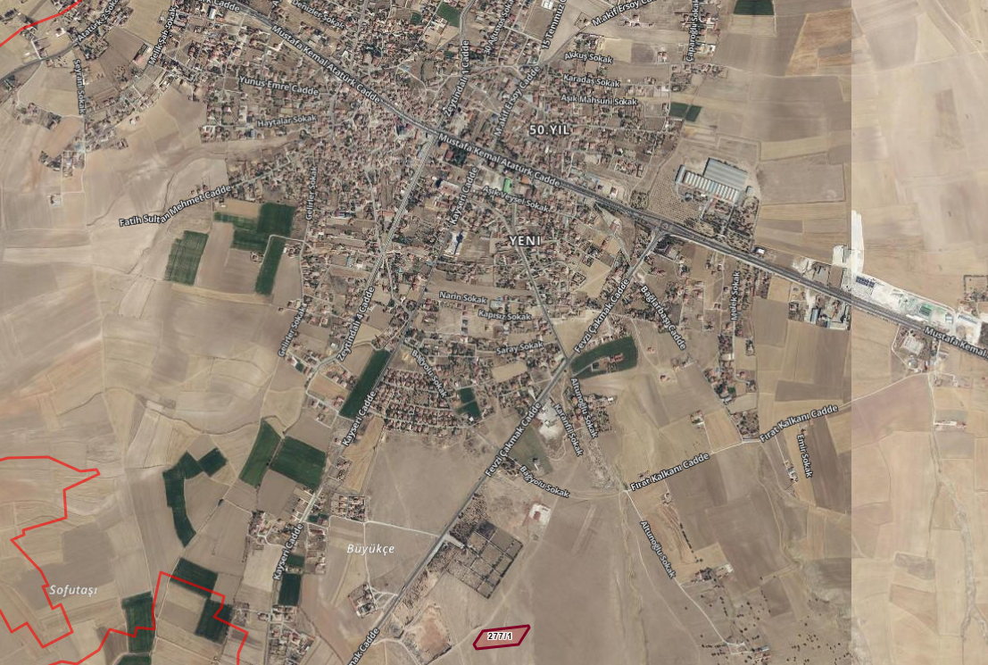

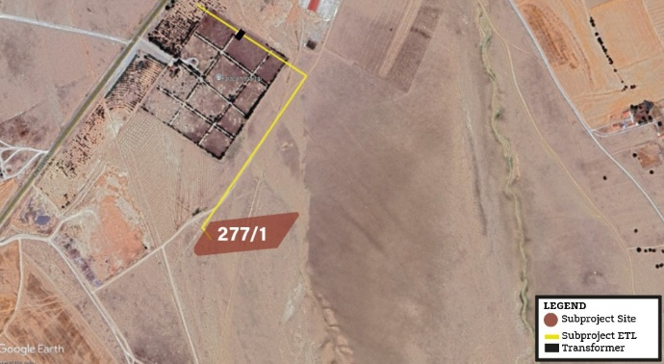

Figure 1: Kalaba Municipality SPP Project Area

**An Environmental and Social Management Plan (ESMP) has been developed to manage the expected impacts.**

The ESMP is prepared to monitor and assess potential environmental and social impacts and risks over the life of the sub-project and to propose mitigation measures for significant adverse environmental impacts.

Monitoring and audit activities to be implemented within the scope of the ESMP will also be defined. Within the scope of ESMP studies, impacts that may occur such as soil and air environments, noise, odor, water resources, wastes, traffic, ecosystem, existing natural disaster risks related to the area where the sub-project will be established, reflection and glare effects that may be experienced due to SPP will be determined and relevant avoidance mitigation measures will be specified.

Monitoring requirements will also be defined and presented in the monitoring tables within the ESMP. Accordingly, during the construction phase of the sub-project, topsoil loss and compression, soil and water pollution due to leaching of pollutants and chemicals into the soil and groundwater, dust emissions, noise during construction of the sub-project and from temporary traffic load, waste generation and occupational health and safety, and during the operation phase, storage and use of chemicals, wastes, noise, reflection and glare impact of the power plant, livelihoods, grievances, community conflicts, stakeholder engagement, occupational health and safety and labor parameters will be monitored in accordance with the requirements set out in the ESMP.

The main institution responsible for the implementation of this Environmental and Social Management Plan (ESMP) is the Municipality of Kalaba, which is also responsible for the construction and operation phases of the sub-project. In addition, various parties at different stages of the sub-project (Contractors, Consulting firm, sub-project Implementation Unit, ILBANK, etc.) They will take responsibility for various issues within the scope of ESMP. All the mentioned works will be coordinated by the Municipality of Kalaba.

The sub-project documents will also be published on the website of Kalaba Municipality and if requested, these documents will be shared by Kalaba Municipality.

Sub-project documents will also be published on Kalaba Municipality’s website and will be shared by Kalaba Municipality upon request.

Kalaba Municipality has established a **Grievance Mechanism** to receive, resolve and follow up on the concerns and grievances of sub-project affected communities. All grievances will be effectively received, recorded and responded to within a predetermined timeline and according to their content. Kalaba Municipality will be the responsible institution for the establishment and implementation of the Grievance Mechanism. In this context, the communication channels given below can also be used to share expectations, opinions, suggestions and complaints about the sub-project.

# Public Engagement Meetings:

# Kalaba Municipality:

**Telephone: +90 (384) 561 20 27**

[**E-mail:**](mailto:E-mail:) **https://www.kalaba.bel.tr/**

All internal and external stakeholders will also have the right to make use of other grievance mechanisms, such as the Presidency’s Communication Center (CIMER), which is accessible to all sub-project stakeholders and is used nationwide, as an alternative and well-known channel to communicate sub-project-related complaints and feedback directly to government authorities.

# [www.cimer.gov.tr](http://www.cimer.gov.tr/)

* + - **Call Center :150**
    - **Telephone Number: 0(312) 590 20 00**

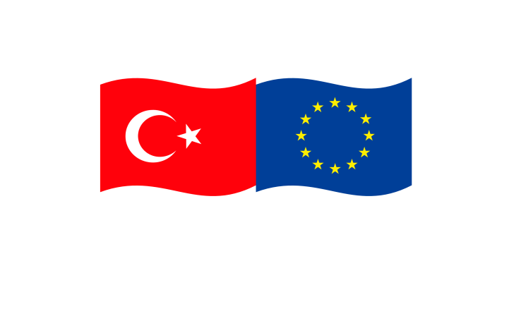

*This project is co-funded by the European Union, the Republic of Türkiye and the World Bank.*

*Bu proje, Avrupa Birliği, Türkiye Cumhuriyeti ve Dünya Bankası tarafından ortaklaşa finanse edilmektedir.*

**TÜRKİYE PUBLIC AND MUNICIPAL RENEWABLE ENERGY PROJECT**

**(PUMREP)**

**Kalaba Municipality**

**Solar Power Plant Project**

Public Consultation Meeting Brochure

10/06/2025

15:00

Kalaba Municipality

