TÜRKİYE PUBLIC AND MUNICIPAL RENEWABLE ENERGY PROJECT

(PUMREP)

**976.64 kWp / 720 kWe SOLAR POWER PLANT PROJECT OF KALABA MUNICIPALITY**

**STAKEHOLDER ENGAGEMENT PLAN**

**JULY 2025**

REVISION HISTORY

|  |  |  |  |  |
| --- | --- | --- | --- | --- |
| Version No | Version | Date of Issue | Prepared by | Submitted to |
| 01 | Initial Draft | 24.02.2025 | ÇA Engineering | İLBANK |
| 02 | Draft | 15.04.2025 | ÇA Engineering | İLBANK |
| 03 | Draft | 29.04.2025 | ÇA Engineering | İLBANK |
| 04 | Draft | 13.05.2025 | ÇA Engineering | İLBANK |

# TABLE OF CONTENTS

TABLE OF CONTENTS i

LIST OF TABLES iii

LIST OF FIGURES iv

LIST OF ABBREVIATIONS v

EXECUTIVE SUMMARY 6

1. INTRODUCTION/PROJECT DESCRIPTION 8

1.1. Objectives 8

1.2. Components 9

1.3. Location 9

1.4. Area of Influence 10

2. OBJECTIVE/ DESCRIPTION OF SEP 12

3. STAKEHOLDER IDENTIFICATION AND ANALYSIS 13

3.1. Methodology 13

3.2. Project Affected Parties 14

3.3. Other Interested Parties 14

3.4. Disadvantaged/ vulnerable individuals or groups 14

4. STAKEHOLDER ENGAGEMENT PROGRAM 17

4.1. Summary of stakeholder engagement done during project preparation 17

4.2. Summary of project stakeholder needs and methods, tools, and techniques for stakeholder engagement 18

4.3. Stakeholder engagement plan 18

4.4. Reporting back to stakeholders 23

5. RESOURCES AND RESPONSIBILITIES FOR IMPLEMENTING STAKEHOLDER ENGAGEMENT ACTIVITIES 24

5.1. Project Implementation Unit (PIU) 24

5.2. Resources 24

5.3. Management functions and responsibilities 24

6. GRIEVANCE MECHANISM 26

6.1. Grievance Mechanism at National Level 26

6.2. Sub Project Level Grievance Mechanism 26

6.3. Grievance Mechanism for Workers 28

6.4. Grievance Mechanism Flow Chart 29

7. MONITORING AND REPORTING 31

7.1. Summary of how SEP implementation will be monitored and reported 31

7.2. Reporting back to stakeholder groups 31

ANNEXES 33

Annex-A 33

Annex-B 35

Annex- C 36

Annex-D 37

Annex-E 38

Annex-F 39

Annex-G 46

# LIST OF TABLES

Table 1. Location of Sub-project and ETL 8

Table 2. 50. Yıl and Yeni Neighborhood vulnerable and disadvantage groups 13

Table 3. Influence/Interest Table for Stakeholder Prioritization 14

Table 4. Stakeholder Engagement Plan 19

Table 5. Roles and Responsibilities 23

Table 6. Grievance Mechanism Flow Chart 27

# 

# LIST OF FIGURES

Figure 1. Location of Sub-project 9

Figure 2. Sub-project Area of Influence 10

# LIST OF ABBREVIATIONS

|  |  |
| --- | --- |
| AoI | Area of Influence |
| CIMER | Presidency’s Communication Centre |
| DC | Distributing center |
| DG | Directorate General |
| EIA | Environmental Impact Assessment |
| ESF | Environmental and Social Framework |
| ESMP | Environmental and Social Management Plan |
| ESMR | Environmental and Social Management Report |
| ESMS | Environmental and Social Management System |
| ESS | Environmental and Social Standard |
| ETL | Energy Transmission Line |
| E&S | Environmental and Social |
| FI | Financial Intermediary |
| GBV | Gender Based Violence |
| GM | Grievance Mechanism |
| GMCP | Grievance Mechanism Contact Personnel |
| IFC | International Finance Corporation |
| IFI | International Financial Institutions |
| ILBANK | İller Bankası A.Ş. |
| MoEUCC | Ministry of Environment, Urbanization and Climate Change |
| MoM | Minutes of Public Participation Meeting |
| NGO | Non-Governmental Organizations |
| OG | Medium Voltage |
| OHS | Occupational Health and Safety |
| PAP | Project Affected People |
| OIP | Other Interested Parties |
| PMU | Project Management Unit |
| PIU | Project Implementation Unit |
| PUMREP | The Turkish Public and Municipal Renewable Energy Project |
| PPO | Public Social Organization |
| Project | PUMREP |
| RE | Renewable Energy |
| SEA/SH | Sexual Exploitation and Abuse/Sexual Harassment |
| SEP | Stakeholder Engagement Plan |
| Sub-Project | 976.64 kWp / 720 kWe Solar (Photovoltaic) Power Plant Project of Kalaba Municipality |
| SPP | Solar Power Plant |
| TurkStat | Turkish Statistical Institute |
| WB  YIMER | World Bank  Foreigners Communication Centre |

# EXECUTIVE SUMMARY

The Türkiye Public and Municipal Renewable Energy Project (PUMREP) aims to support the Government of Türkiye to scale-up renewable energy use in the public sector by focusing on central government buildings and municipalities. The Project will contribute to expanding the distributed Renewable Energy (RE) market in public facilities by addressing the barriers discussed above and help demonstrate leadership in the public sector to use sustainable energy solutions to deliver on the country’s climate mitigation commitment and enhance energy security.

The PUMREP will support introducing RE technologies in municipalities and will be implemented by İller Bankası A.Ş. (ILBANK). The RE installations will be primarily used to offset the overall energy consumption from public facilities (e.g., administrative buildings, water supply and water treatment, public lighting, etc.) and thus reduce the municipalities’ energy bills. A preliminary pipeline of about 100 subprojects has been provided by ILBANK, including the tentative capacity of the RE installations (ranging from 0.2 MW to 5 MW), required investment costs, and the status of grid connection permits. Although most of these proposed subprojects are solar PV (both rooftop and ground-mounted), other RE technologies may also be considered for support during project preparation. The eligibility criteria for RE technologies and sub-project locations will be finalized during the Project preparation stage.

ILBANK has established an Environmental and Social Management System (ESMS) effective on 24th of Dec 2023. The ESMS is aimed at ensuring systematic identification, assessment, management, monitoring, and reporting of the environmental and social (E&S) risks and impacts of the projects and subprojects financed by the IFIs. This process should be implemented on an ongoing basis throughout their loan duration in line with the requirements of the national legislation, international agreements and conventions ratified by Türkiye and E&S standards of lending IFIs (World Bank for the PUMREP). As a critical element of the ESMS, ILBANK has adopted and published an E&S Policy applicable to all ILBANK projects and subprojects financed through IFIs.

“976.64 kWp / 720 kWe Solar Power Plant Project" (sub-project) is planned to be carried out by Kalaba Municipality in the Kalaba town, Avanos, Nevşehir province, on the lot 1 of block 277 have a total area of 13,960 m2, and will be fully utilized in sub-project activities. The subproject area is owned by the Kalaba Municipality

This SEP has been formulated to ensure that project affected interested parties, other interest parties and vulnerable groups that constitute the stakeholders are provided relevant, timely and accessible information so that they have an opportunity to express their views and concerns about the sub-project and its impacts.

SEP establishes a systematic approach to stakeholder engagement that will help Kalaba Municipality to identify all stakeholders and how they will be affected by the sub-project and ensure that the sub-project is implemented in a participatory and community-friendly manner through building and maintaining a continuous constructive relationship with them, in particular with project-affected parties.

SEP also assesses the level of stakeholder interest and support for the sub-project and guides the relations of the Kalaba Municipality team with the stakeholders throughout the construction and operation process, enabling stakeholders’ views to be taken into account in sub-project design and environmental and social performance.

SEP is designed to ensure that relevant sub-project information on environmental and social risks and impacts is disclosed to stakeholders in a timely, understandable, accessible and appropriate manner and format.

The sub-project is categorized as Moderate Risk Category as per ILBANK ESMS and World Bank’s Environmental and Social Framework (WB ESF), 2018. One of the tasks under the scope of the Project is the preparation of a Stakeholder Engagement Plan (SEP) in accordance with ILBANK ESMS, WB ESF, and the national legislation in force in Türkiye. This Stakeholder Engagement Plan (SEP) is therefore prepared to identify all stakeholders, inform them about the project and its potential environmental and social risks and impacts, and their interest in the sub-project and to establish an effective communication with stakeholders and to define procedures and principles to improve engagement. This Plan aims to create long-term relations between the sub-project and local communities based on mutual trust and transparency. In addition, it is aimed to reduce the negative effects that may arise from the project and increase the positive effects. By implementation of this SEP, stakeholders will be able to access to the information about the sub-project, its investments, installation works and operation activities in a timely manner. This plan includes the legal framework, process of identifying stakeholders, explaining the stakeholder engagement program (comprising purpose and timing, proposed strategy for information disclosure, proposed strategy for consultation, future engagement activities, grievance mechanism covering receiving and closing grievances, taking necessary actions and management of grievances). In addition, specific engagement and disclosure activities targeting vulnerable/disadvantaged groups/individuals identified under the SEP have been defined.

In order to obtain information about the current socio-economic structure of the neighborhood in the subject area studies, as well as to determine the level of information about the sub- project, opinions and concerns about the sub-project, a sub-project site visit was organized by CA Engineering Environmental Expert on 23.09.2024. Finally, a Grievance Monitoring Table is presented at the end of this SEP and the tools of monitoring activities to be carried out to evaluate the performance and effectiveness of the sub-project are suggested.

# INTRODUCTION/PROJECT DESCRIPTION

The Public and Municipal Renewable Energy Project (PUMREP) (hereinafter the “Project”) aims to support the Government of Türkiye to scale-up Renewable Energy (RE) use in the public sector by focusing on central government buildings and municipalities. The sub-project involves the establishment and operation of "Kalaba Municipality 976.64 kWp / 720 kWe Solar Power Plant, located within the borders of Kalaba Town in the Avanos District of Nevşehir Province The Project is financed by World Bank (WB) to support introducing RE technologies in municipalities. İller Bankası A.Ş. (ILBANK) acts as the Financial Intermediary (FI). The RE installations will be primarily used to offset the overall energy consumption from public facilities (i.e. administrative buildings, water supply and water treatment, public lighting, etc.) and thus reduce the municipalities’ energy bills.

The potential environmental and social risks and impacts of the Project is provided in the Environmental and Social Management Plan (ESMP) which is available at [link[1] ]. The Project’s environmental and social risk classification is determined as moderate.

This document is prepared in accordance with Environmental and Social Standard (ESS) 10 on Stakeholder Engagement and Information Disclosure, as part of the Environmental and Social Framework (ESF) Kalaba Municipality is responsible for stakeholder engagement activities and grievance resolution, ensuring that the sub-project is carried out in an inclusive and participatory manner.

## Objectives

This Stakeholder Engagement Plan (SEP) has been developed to ensure that project-affected persons (PAPs), vulnerable and disadvantaged groups, other interested parties, as well as direct and contracted employees, are provided with relevant, timely, and accessible information. The aim is to enable these stakeholders to express their views and concerns regarding the sub-project and its potential environmental and social impacts.

The objectives of the SEP are as follows:

• Identify and meaningfully engage all potentially affected and interested stakeholders to ensure their active participation in the sub-project lifecycle,

• Develop a comprehensive understanding of the sub-project among stakeholders to facilitate effective engagement and informed decision-making,

• Identify and address potential risks that may impact the sub-project or its stakeholders at an early stage,

• Ensure the development and implementation of appropriate, effective, and efficient mitigation measures for identified risks,

• Establish and maintain a long-term communication channels between the sub-project and stakeholders to promote collaboration.

The SEP's specific objectives include the following:

• Define a consultation approach for stakeholders regarding the construction and operation phases of the sub-project,

• Determine resources and responsibilities for the implementation and monitoring of the consultation program,

• Establish a comprehensive grievance mechanism (GM) for all stakeholders (including direct and contract workers) to raise and address concerns efficiently and transparently.

This SEP will guide Kalaba Municipality to implement structured stakeholder consultation and engagement in all phases of sub-project implementation in accordance with applicable national and international regulations and WB requirements on stakeholder engagement, particularly İLBANK ESMS and World Bank’s ESF. The SEP will be revised and updated as necessary during project implementation.

## Components

The sub-project involves the establishment of solar power plants (SPP) on lot 1 of block 277. Kalaba Municipality solar energy project plant will be connected to the grid with a 691-meter long underground energy transmission line in accordance with the permits given by MERAM EDAS. The energy transmission line to be built does not pass through private land along its route. It passes through the development road located within the parcel Lot 1 of block 286. The property of Lot 1 of block 286 belongs to the Kalaba Municipality. Additionally, the existing stabilized road will be used as the sub-project access road within the scope of the sub-project. A new road will not be constructed.

## Location

The sub-project involves the establishment and operation of "976.64 kWp/720 kWe Solar Power Plant” by Kalaba Municipality on lot 1 of block 277 located within the borders of Kalaba Town Neighborhood in the Central District of Kalaba Province. The ETL route will pass through the development road located within the parcel Lot 1 of block 286. The property of Lot 1 of block 286 belongs to the Kalaba Municipality.

There is no agricultural or animal husbandry activity area or commercial enterprise on the land. It has not been used as a commercial enterprise by the municipality or 3rd parties before. There is no area around the SPP land where agricultural and livestock activities are carried out.

Table 1. Location of Sub-project and ETL

|  |  |  |  |  |  |
| --- | --- | --- | --- | --- | --- |
| **Province** | **Distirct** | **Town** | **Project Component** | **Block** | **Lot** |
| Nevşehir | Avanos | Kalaba | Solar Power Plant (SPP) | 277 | 1 |
| Nevşehir | Avanos | Kalaba | ETL | 286 | 1 |

|  |
| --- |
|  |

Figure 1. Location of Sub-project

## Area of Influence

The Area of Influence (AoI) for the sub-project is determined based on the anticipated environmental and social impacts during the construction, operation, and maintenance phases of the project, such as local ecosystems, nearby communities, and critical infrastructure.

The SPP sub-project is located in the Kalaba Town. The site is approximately 450 meters away from the neighborhood. The transportation route passes through the town but does not intersect with sensitive structures such as health and school. Therefore, no traffic impact is expected during transportation and equipment transportation to the site.

Within the scope of sub-project activities, the impact area was determined as a result of interviews with local people and mukhtars during the site visit on 23.09.2024, based on components such as dust emissions, environmental noise, provision of local employment, local people's opinions about the sub-project, etc.

According to the construction phase dust emissions and environmental noise calculations explained in detail in the ESMP report, the noise levels that will occur at the project site are dampened after a distance of 100 m and remain below the 65 dBA noise level limit value specified in Table 1 of Annex II of the "Environmental Noise Control Regulation" published in the Official Gazette dated 30.11.2022 and numbered 32029. The sub-project area of ​​influence is shared in Figure 2.

Since the dust emission that will occur as a result of the calculations made under controlled conditions for the construction phase remained below the 1.0 kg/hour value given in Annex 2 of the Regulation on Control of Industrial Air Pollution, which was published in the Official Gazette dated 03.07.2009 and numbered 27277 and entered into force, there was no need to conduct air quality modeling studies.

It passes through the ETL 286/1 parcel, which is located within the sub-project impact area and will connect the facility to the grid. The Kalaba Town cemetery is located within this parcel. During the field visit on the subject, local people, 50. Yıl and Yeni neighborhood headmen were also interviewed. Their concerns about the cemetery area due to sub-project activities were discussed. It was determined that they did not have a negative opinion because the existing transformer is located within the cemetery area.

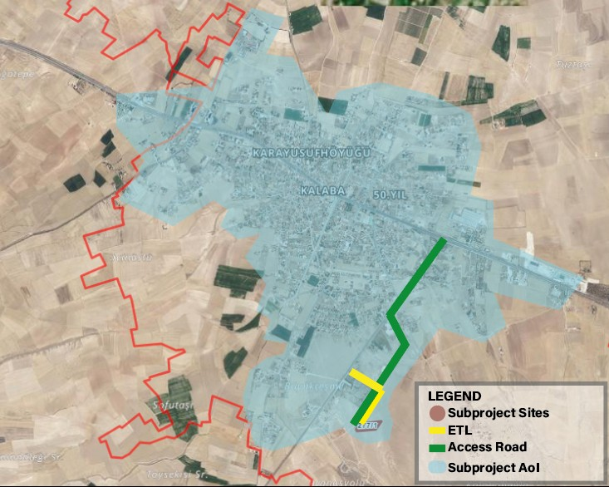

Figure 2. Sub-project Area of Influence

# OBJECTIVE/ DESCRIPTION OF SEP

The overall objective of this SEP is to define a program for stakeholder engagement, including public information disclosure and consultation throughout the entire project cycle. The SEP outlines how the Kalaba Municipality PIU (Project Implementation Unit) will communicate with stakeholders and includes a mechanism by which people can raise concerns, provide feedback, or make complaints about project activities or related issues. The SEP specifically emphasizes methods to engage with vulnerable groups, who are at risk of being excluded from the project benefits.

As an important tool in the management of the environmental and social impacts of the sub-project, SEP increases awareness of the sub-project, identifies stakeholders’ views, ensures that their opinions and concerns are taken into consideration, and increases trust in the sub-project processes. The Stakeholder Engagement Plan (SEP) aims to support Kalaba Municipality in identifying its stakeholders and fostering constructive relationships, particularly with those affected by the sub-project.

The SEP promotes effective and inclusive engagement with affected parties throughout the project lifecycle, addressing potentially impactful issues. It ensures that information on environmental and social risks and impacts are disclosed in a timely, understandable, and accessible manner. Additionally, the SEP provides affected parties with inclusive tools to voice concerns and grievances, enabling Kalaba Municipality to respond and manage these effectively. By creating a transparent and respectful environment, the SEP encourages the inclusion of diverse cultural norms and engagement capacities, fostering fair and open dialogue to address stakeholder concerns engagement.

# STAKEHOLDER IDENTIFICATION AND ANALYSIS

In the stakeholder identification process, the potential impacts of the sub-project are assessed, and strategies for engaging with stakeholders are developed, including the frequency and methods of communication. It is especially important to focus on identifying vulnerable or disadvantaged groups who may be more severely affected by the sub-project or face challenges in participating in the engagement process. Identifying stakeholders is an ongoing activity and will be continuously reviewed and updated as needed.

## Methodology

To follow best practices in stakeholder engagement, the project will apply the following principles:

**Openness and Life-cycle Approach**: Public consultations will be held throughout the entire project life cycle in an open and transparent way, ensuring that there is no outside influence, manipulation, or intimidation.

**Informed Participation and Feedback**: Relevant information will be shared with all stakeholders in an accessible format. There will be opportunities for stakeholders to provide feedback, and their comments and concerns will be carefully analyzed and addressed.

**Inclusiveness and Sensitivity**: The stakeholder identification process will focus on building strong, effective relationships and ensuring that all stakeholders are included in the consultation process. Everyone will have equal access to information. Engagement methods will be chosen based on the needs of the stakeholders, with particular attention to vulnerable groups such as women, the elderly, people with disabilities, displaced persons, migrant workers, and communities. Cultural sensitivities will also be carefully considered to ensure the participation of diverse ethnic groups.

Stakeholder identification follows an overall analysis of sub-project's scope, objectives, and potential impacts. Each stakeholder group is assessed for their interest and influence on the sub -project as well as for their potential exposure and vulnerability to sub-project impacts. The preliminary step is to designate the affected parties and other interested parties and analyze the level of influence and/or interest for each group.

The intensity of the impacts requires interaction in different ways in terms of engagement. During the mapping process of the stakeholders, the nature of the sub-project impacts are identified, and the methods and frequencies of the relations to be built with stakeholders are formulated. It is critical that particular efforts are given to identify disadvantaged and vulnerable stakeholders who may be differentially or disproportionately affected by the sub-project or who may have difficulty participating in the engagement and development processes. Stakeholder identification is also an ongoing process and will need to be regularly reviewed and updated.

To ensure a meaningful consultation process regarding the sub-project, it is crucial to identify relevant stakeholders. In this context, a site visit was conducted by the ÇA Engineering firm on September 23, 2024. During the site visit, meetings were held with Kalaba Municipality officials, and information about the sub-project sites was gathered through on-site inspections. In this regard, meetings were conducted with the mukhtars of Yeni and 50. Yıl Neighborhood.

Discussions with the mukhtar included topics such as the demographic status of the town, suggestions and concerns regarding the sub-project. Meetings also covered the socio-economic and demographic structures, as well as infrastructure services of Kalaba town. Additionally, individual consultations were held with four residents of Kalaba town to gather their opinions, suggestions, and concerns about the sub-project. During the field visit to the sub-project areas, it was determined that there were no official or unofficial users and that the lands were not used by the local people for agriculture, animal husbandry and grazing activities. All data specified in the report were processed based on the mukhtar interviews conducted during the field visit and the information received from the local people

After determining the impacts of the sub-project, the first step of the stakeholder engagement process will be to determine the stakeholders of the sub-project. While determining the stakeholders, Kalaba Municipality will also determine the needs and expectations for engagement, including the priorities and goals related to the sub-project.

Stakeholders will be defined as follows in accordance with ESS10;

- Project affected parties (PAPs),

- Other interested parties (OIPs),

- Vulnerable and disadvantaged groups.

## Project Affected Parties

The term "project-affected parties" refers to individuals or groups who are likely to be affected by the sub-project due to direct impacts or potential risks on their physical environment, health, safety, cultural practices.

The key direct stakeholders who will be cooperated and consulted about and during the sub-project, including individuals, groups and communities are:

Communities likely to be affected by the construction works in the scope of component

Workers to be employed for the construction activities

## Other Interested Parties

Other interested parties (OIP)s include individuals, groups and others who may have an interest in the sub-project because of their location, proximity to natural or other resources, or the sector or parties involved in the sub-project. This may include local government officials, community leaders, media and civil society organizations, particularly those working in or with affected communities.

Maintaining regular relationships with media stakeholders is sufficient to provide regular information at local and national level in Nevşehir Province. In all cases, the media plays an important role in informing the public and building public perception of the sub-project.

## Disadvantaged/ vulnerable individuals or groups

Disadvantaged/Vulnerable individuals or groups are persons who may be disproportionately impacted or further disadvantaged by the project(s) compared with any other groups due to their vulnerable status, and that may require special engagement efforts to ensure their equal representation in the consultation and decision-making process associated with the project.

However, vulnerable and disadvantaged groups residing in 50. Yıl and Yeni Neighborhoods, where the sub-project activities will be carried out, may be indirectly affected due to their limited ability to express concerns, understand the interests of the sub-project, or access and comprehend project-related information.

Details of Vulnerable and Disadvantage Groups according to the information obtained from the mukhtar of Yeni Neighborhood, the closest settlement to the sub-project site, are given in Table 2

Table 2. 50. Yıl and Yeni Neighborhood vulnerable and disadvantage groups

|  |  |
| --- | --- |
| **Vulnerable and Disadvantage Groups** | **Number of People**  **(50. Yıl and Yeni Neighborhood)** |
| Physically and/or mentally disabled people | 5 |
| Chronic diseases people | 80 |
| The number of people living in low-income households was determined | 5 |
| People over 70 years of age and live alone | 50 |
| Female households heads | 38 |
| Children acting as heads of their households | 7 |
| Total Vulnerable and Disadvantage Groups | 185 |

***Source: Mukhtar Meetings, 2024.***

According to the interviews conducted with mukhtar of Yeni neighborhoods on 23.09.2024 during the consultations carried out within the scope of SEP and the information received from the municipality staff (Annex-E), there are no refugee residing in the sub-project area. Disabled individuals, chronically ill individuals, low-income individuals, individuals over the age of 70 and living alone, children and female heads of households located in the sub-project area may have difficulty accessing sub-project activities due to socio-economic, health problems or life flows. Within the sub-project area, there is no structure. Additionally, the nearest occupied houses are located approximately 450 meters from the sub-project site. However, programs will be developed to facilitate the engagement of the vulnerable/disadvantaged groups/individuals in consultations. In the event of any employment opportunity for the unemployed within the scope of the subproject, an announcement will be made to the mukhtars' offices and local people will be prioritized in recruitment. There is no language spoken in the region other than Turkish. According to the information received, there are approximately 761 female in 50. Yıl and Yeni Neighborhoods. Therefore, the female population in 50. Yıl and Yeni Neighborhoods, which is indirectly affected by the sub-project, constitutes 54% of the total population. The literacy rate of women in the region is very low. Therefore, it is difficult for women to participate in stakeholder engagement activities. In addition, the presence of women in the public sphere in the region is limited. In order to inform them about stakeholder engagement activities, verbal information will be provided to women parent groups in Quran courses and primary and secondary schools in the neighborhood.

Programs will be developed so that the Vulnerable and Disadvantage Groups, whose details are provided in Table 2 do not have difficulties in participating in the consultation activities and events. A shuttle service will be provided to ensure that the said group participates in the consultation meetings. They will be picked up from their homes and returned to their homes upon completion of the event.

During the sub-project site visit, the mukhtar, local authorities and local residents were questioned about the existence of cultural heritage. No tangible or intangible cultural heritage assets were identified in the sub-project site and within the AoI. ETL will follow the cadastral road starting from lot 1 of block 277 parcel and then will be connected to the transformer located in lot 1 of block 286 parcel. The ownership of lot 1 of block 286 parcel where the cemetery is located belongs to Kalaba Municipality. There is no need for expropriation within the scope of the sub-project.

How each stakeholder group will be affected by the project and their interest in the project; the area of influence and the nature and quantity of the impacts that may arise were determined. The stakeholders determined as a result of the interviews with the mukhtar of Yeni neighborhood and local people, interviews with non-governmental organizations, public institutions and organizations and the information obtained from Kalaba Municipality are given in Table 3.

Table 3. Influence/Interest Table for Stakeholder Prioritization

|  |  |  |  |  |
| --- | --- | --- | --- | --- |
| **Stakeholder Group** | | | **Level of Interest** | **Level of Influence** |
| Stakeholder | Project Affected Parties | * Communities likely to be affected by the construction works in the scope of component (Yeni Neighborhood) * Workers to be employed for the construction activities | High | High |
| Other Interested Parties | **Public Institutions**  Ministry of Environment, Urbanization and Climate Change (MoEUCC)  Ministry of Labor and Social Security   * General Directorate of Labor * General Directorate of Occupational Health and Safety   Nevşehir Governorship   * Provincial Directorate of Environment, Urbanization and Climate Change   + Branch Directorate Responsible for EIA and Environmental Permits   + Branch Directorate Responsible for Environmental Management and Inspection   + Branch Directorate Responsible for Natural Assets Protection * Social Security Institution Provincial Directorate * Provincial Directorate of Environment, Urbanization and Climate Change   Nevşehir Provincial Directorate of Civil Society Relations  Centre District Governorship  Nevşehir Environment, City and Culture Presidency   * Kayseri Regional Directorate of ILBANK | High | Low |
| **NGOs**   * Nevsehir Environmental Protection Association |
| **Local Press**   * “Kapadokya Muşkara” Newspaper * “Kızılırmak” Newspaper * “Nevşehir Kent Haber” Newspaper   **National Press**   * Anadolu Agency * Demirören News Agency |
| **University**  Nevşehir Hacı Bektaş Veli University |
| Vulnerable and Disadvantaged or groups | | 185 people living in 50. Yıl and Yeni Neighborhoods   * Physically and mentally disabled * Chronic diseases people * The number of people living in low-income households was determined People over 70 years of age and live alone * Female household heads * Children who are heads of households | Moderate | High |

# STAKEHOLDER ENGAGEMENT PROGRAM

The main objectives of the stakeholder engagement program and the planned timetable for the various stakeholder engagement activities are to define at what stages and at what intervals these activities will be carried out throughout the life of the sub-project. Information is provided on how the public will be made aware of future opportunities to review information and provide their views, if decisions about public meetings, locations and timing of meetings have not yet been made.

## 4.1. Summary of stakeholder engagement done during project preparation

In order to inform the public about the sub-project, a field visit was carried out on 23.09.2024 to engage with the local community, gather their opinions and suggestions, and provide detailed information about the subproject. As a part of this process, an interview was conducted with the 50. Yıl and Yeni neighborhoods mukhtars and Kalaba Municipality officials about the usage status of the sub-project site and the disadvantaged groups living in the region. Within the scope of the interviews;

* It was determined that the sub-project site was not currently used by the local people for any purpose, and that there were no refugees living in 50. Yıl and Yeni neighborhoods, the closest settlement to the sub-project site.
* In addition, within the scope of the Stakeholder Engagement Plan, consultation meetings were held with 50. Yıl and Yeni neighborhoods residents (3 people) and the association president by CA Engineering on 23.09.2024. In order to obtain general information about the socio-economic situation of 50. Yıl and Yeni neighborhoods and to learn about their knowledge levels about the sub-project, a "Community Level Survey (See Annex-F)" form was filled out by the consultant company as a result of interviews with the mukhtar of Yeni neighborhood.

As part of the stakeholder engagement efforts for the Kalaba Municipality Solar Power Plant Project, a public consultation meeting was held on 10.06.2025 in Kalaba Municipality Condolence House with the participation of local residents, municipal representatives, and other relevant stakeholders. The purpose of the meeting was to inform the community about the sub-project, provide a platform for discussion, and collect feedback regarding potential environmental and social impacts.

Prior to the meeting, announcements were made through local channels such as neighborhood mukhtars and municipal communication tools to ensure community awareness and encourage participation 10 days before the meeting. A total of 29 municipal staff members and 11 local residents attended the meeting, representing the primary stakeholders in the sub project area.

During the session, detailed information was shared on the location and scope of the solar power plant, its technical components, anticipated energy generation and carbon emission reductions, as well as the use of public and municipal lands. Potential environmental and social impacts—particularly during the construction phase, such as dust, noise, and increased traffic—were also discussed. Participants were informed about the environmental and social mitigation measures outlined in the Environmental and Social Management Plan (ESMP) and were introduced to the grievance redress mechanism available throughout the project lifecycle.

Among the issues raised by the participants were whether the panels had an effect on temperature increase and whether noise was expected during the operation process. All questions were addressed by project representatives, and it was emphasized that the feedback received would be considered during the implementation phase.

Overall, the consultation contributed to strengthening community awareness and promoting transparency. It demonstrated the municipality’s commitment to open dialogue and ongoing stakeholder engagement. A copy of the meeting minutes, signed participant list, and photographic documentation are provided in Annex-G.

## 4.2. Summary of project stakeholder needs and methods, tools, and techniques for stakeholder engagement

Identifying and managing stakeholder needs accurately in Solar Power Plant (SPP) projects is critically important for the success of the project. Key stakeholder needs include regular updates about the sub-project, inclusion of stakeholders in decision-making processes, informing them about the direct or indirect benefits of the project, and establishment of an effective communication mechanism. Tools such as surveys, workshops, and one-on-one interviews will be effectively utilized in information-sharing and engagement processes. Additionally, regular reporting, dashboards, and online communication tools will ensure transparent updates about sub-project progress. Community meetings and feedback mechanisms will help build trust in the sub-project while providing a better understanding of stakeholders' needs and expectations. Through these methods, stakeholder engagement in SPP projects will be strengthened, making the projects more inclusive, sustainable, and effectively managed.

This plan shows the nature and level of stakeholder interest in the project, how the engagement will be conducted, the frequency of engagement and the responsible unit of Kalaba Municipality, and the following matrix provides a tabular version of this program (See Table 4).

The responsible party/person should be determined by the representatives of Kalaba Municipality. The SEP will be implemented at the sub-project level. Consultation forms and full meeting minutes of those who participated in the consultations will be recorded, but will not be made publicly available as an annex to the SEP. When the SEP is disclosed, relevant data containing personal data will be blurred, taking into account the Personal Data Protection Law.

All supporting documentation for stakeholder activities (newspaper notices, attendee list, full meeting minutes (as an annex), sample brochure) will be included in the SEP.

The Minutes of Stakeholder Consultation Meetings (MoM) will be reported and disclosed. A shuttle service will be provided to ensure the participation of disadvantaged and vulnerable groups, and online participation will be provided for groups that still cannot participate.

In the participation of women in consultation activities, meetings will be held under conditions that take cultural sensitivities into account. In addition, meetings will be planned at appropriate times (e.g. evenings or weekends) depending on their age and workload.

In order to inform about stakeholder participation activities, visual and verbal information will be provided to neighborhood Quran courses and female parent groups in primary and secondary schools. If necessary, support will be requested from NGOs that have gained trust by relevant groups at the local level.

## 4.3. Stakeholder engagement plan

The main objectives of the stakeholder engagement plan are to provide early information, explanation and consultation on various project documents and activities in order to establish a dialogue with project stakeholders from planning to implementation and operation. All environmental and social documents prepared in anticipation of the financing agreement from the World Bank will be disclosed and consulted before the sub-project appraisal takes place.

Final decisions on public meetings, locations and timing of meetings have not yet been determined. Kalaba Municipality will ensure that the sub-project is communicated to all stakeholders and that meaningful engagement and consultation activities are carried out. Consultation activities are designed with some basic guiding principles, including the following:

* Consultations should be widely advertised, especially among stakeholders, preferably 10 days before any meeting or engagement.
* A non-technical briefing should be provided prior to any event to ensure that people are informed about the assessment and results.
* The location and timing of meetings should be designed to maximize stakeholder engagement and compliance.
* The information provided should be clear and non-technical.
* Engagement should be facilitated so that stakeholders can voice their views and concerns.
* Any issues that arise should be addressed in the meetings or at a later time.

The following information should be included when documenting the stakeholder engagement activities to be carried out within the scope of the sub-project:

* Date(s) and location(s) of the consultation(s) and related notification(s) (newspaper advertisements, screenshots of social media announcements, etc.)
* Participant details (as per the Personal Data Protection Law),
* Meeting schedule/program (as well as information on what was presented and by whom),
* Summary meeting minutes (comments, questions and responses from presenters),
* Review of comments, agreed actions, issues requiring follow-up actions and activities, including clarification of how stakeholders were informed about decisions taken.
* Conduct targeted consultations with vulnerable/disadvantaged individuals/groups within the Kalaba Municipality to understand their concerns/needs regarding access to information, facilities and services supported by the sub-project and other challenges they face in their homes, workplaces and communities.
* To reach these groups, identify leaders and organizations of vulnerable/disadvantaged individuals/groups,
* Create a database of marginalized groups through existing sector associations such as disability organizations,
* Engage community leaders, Public Social Organizations (PPOs) and NGOs working with vulnerable/disadvantaged individuals/groups, and organize face-to-face focus group discussions with these populations when appropriate.
* Organizing small events or meetings for vulnerable/disadvantaged people depending on their sensitivity (e.g. a small meeting with hearing impaired individuals accompanied by a sign language expert),
* For women participants with low literacy levels, the areas where they are concentrated will be determined specifically for the subproject and these areas will be preferred for the participation of the relevant group. For women groups with limited access to health or child care, support will be provided according to their disability needs and child care support will be provided. All information regarding subproject activities will be conveyed in a clear and understandable manner. Participation will be increased by receiving support from NGOs or mukhtars that have gained the trust of women groups.
* Assigning a public communication, social and citizen engagement specialist will help ensure proactive outreach to all population groups.

The proposed Stakeholder Engagement Schedule is provided in Table 4.

Table 4. Stakeholder Engagement Plan

| **Project Stage** | **Estimated Date/Time Period** | **Topic of Consultation/ Message** | **Method Used** | **Target Stakeholders** | **Responsibilities** |
| --- | --- | --- | --- | --- | --- |
| Pre-construction |  | **Information Statement**   * General information about the purpose, stages, Project and E&S impacts/risks * Purpose, start date, duration and nature of land preparation, construction and operation activities * Implementation of mitigation measures related to relevant social and environmental impacts/risks * Grievance Mechanism * Information (ESMP and SEP) on Kalaba Municipality website for review * E&S documents (ESMP and SEP) | Face to face meetings  Kalaba Municipality website  Social Media  Notice Boards  Booklets etc.  Posters to be hung in mukhtars offices etc. | Resident of Yeni neighborhood,  Interested parties,  Local communities,  Local government,  Local business  ILBANK | Audit Consultant,  Kalaba Municipality,  E&S Consultant,  Construction Company,  Sub-project Contractors |
| **Employment and Supply Strategies**   * Hiring employees * Staff training * Purchasing materials and services * Grievance Mechanism | face to face meetings  Kalaba Municipality website  Social Media  Notice Boards  Booklets etc.  Posters to be hung in mukhtars offices etc. | Local businesses,  All local communities, association president and local residents |
| **Social progress, economic and social development and environmental protection**   * Mitigation measures against potential   environmental and social impacts/risks   * Grievance Mechanism * Sustainability * Social responsibility sub-projects, implementation principles | Meetings (with NGO representatives and members)  Kalaba Municipality website | NGOs |
|  |  |  |
|  |  |  |
| Construction |  | **Information Statement**   * Monitoring targets and activities to be carried out * Monitoring targets and activities and regular reporting of monitoring results to stakeholders | Public Engagement Meeting  Kalaba Municipality website  Social Media  Notice Boards  Booklets etc.  Posters to be hung in work areas etc. | Resident of 50. Yıl and Yeni Neighborhoods,  Interested parties,  Local communities,  Local government,  Local business  ILBANK | Audit Consultant,  Kalaba Municipality,  E&S Consultant,  Construction Company,  Sub-project Contractors |
| **Social progress, economic and social development and environmental protection**   * Mitigation measures against potential * environmental and social impacts/risks * Grievance Mechanism * Sustainability * Social responsibility sub-projects, implementation principles | Meetings (with NGO representatives and members)  Kalaba Municipality website | NGOs |
| **Traffic and Transport Management**   * Road safety awareness, including safe passage through bypasses and connecting roads * Types, number and frequency of vehicles to be used during construction * Collaboration with local communities and responsible authorities to improve signage, visibility and overall road safety, especially along roads near schools or other places where children are present, * Planning and timing of construction activities on roads, * Regarding training on traffic and pedestrian safety cooperating with local communities (e.g. school education campaigns) * Traffic measures and sub-project road use sharing with association president * Grievance Mechanism | Face-to-face meetings,  Depending on the demands of the stakeholder group,  Posters to be hung in work areas, etc.,  Kalaba Municipality website | All local communities and association president |
| Operation |  | **Information Statement**   * Monitoring targets and activities to be carried out * Monitoring targets and activities and regular reporting of monitoring results to stakeholders * General information about the sub-project, environmental and social impacts, mitigation measures, monitoring activities of the sub-project * Grievance Mechanism | Face to face | Resident of 50. Yıl and Yeni Neighborhoods | Kalaba Municipality |

## 4.4. Reporting back to stakeholders

Stakeholder engagement is a continuous process that begins before the development of the SEP and will continue throughout the life of the sub-project. Kalaba Municipality will actively communicate with the identified stakeholders throughout the life of the sub-project. In particular, Kalaba Municipality will solicit feedback from stakeholders on the E&S performance of the subproject and the implementation of the identified mitigation measures and the Grievance Mechanism. In the event of significant changes in the subproject that lead to risks and impacts that will particularly affect the parties affected by the subproject, Kalaba Municipality will provide information on these risks and impacts and consult with the parties affected by the sub-project on how to mitigate these risks and impacts.

Different information methods and tools can be used to increase the level of information for each of the targeted stakeholder groups. In particular, for Stakeholder Consultation Meetings, the meeting place(s), time and date will be set and this information will be announced to the public at least ten (10) days before the event, ensuring that all community members are informed about the event to be held.

Throughout all stages of the project, comments collected through the website, grievance mechanism, and all stakeholder engagement activities such as public and/or individual meetings will be subject to evaluation and review by the relevant responsible personnel such as the GM Contact Person (GMCP) and the Public Relations Assistant to be assigned by the Project Implementation Unit (PIU).

The contractor and Kalaba Municipality officials will be in regular contact. Face-to-face meetings will be held when necessary, and the contractor and Kalaba Municipality will meet periodically (monthly).

Depending on their content, comments will be evaluated and reviewed both within the PIU and by the relevant responsible personnel of the contractor(s).

If the request or comment cannot be met with the solution method proposed by the commenter or requester to resolve the grievance, alternative solutions will be sought (see Section 6 for more details). A decision will be made as a result of the evaluations and if the final decision cannot be met within a reasonable time frame, it will be communicated to the stakeholder(s) who made the comment or request, together with the justifications and the timeline of actions related to the comment/request. If the comment is not anonymous, the final decision will be communicated to the stakeholder(s) through the communication channel(s) preferred by the stakeholder(s). In addition, a Grievance Close Out Form (see Annex-B) should be filled in and signed by the stakeholder(s).

Stakeholders will be informed as the sub-project develops, including reporting on the environmental and social performance of the sub-project, implementation of the SEP and the grievance mechanism.

During the construction phase, voice announcements will be made by Kalaba Municipality and/or Contractors two (2) days in advance for road restrictions, water cuts and other infrastructure service limitations. Environmental and social performance indicators will be shared with stakeholders monthly via Kalaba Municipality's website[2]

The commencement and completion of the construction activities of the sub-project, changes in the sub-project design and important stages such as commissioning will be communicated to stakeholders through local media channels as much as possible.

Stakeholder definitions will be made in the SEP prepared by the Kalaba Municipality and a consultation meeting will be held with the determined stakeholders.

# RESOURCES AND RESPONSIBILITIES FOR IMPLEMENTING STAKEHOLDER ENGAGEMENT ACTIVITIES

## 5.1. Project Implementation Unit (PIU)

The PIU is established within Kalaba Municipality and consists of Kalaba Municipality personnel. The duties and responsibilities of PIU are explained in Table 5.

Contact details of the responsible personnel are not yet available. Therefore, contact information such as telephone number, address, e-mail address, title, etc. will be provided in this section of the SEP to be updated.

A sufficient budget will be allocated for communication and grievance mechanism to be established with stakeholders. The budget is included in the project budget.

## 5.2. Resources

Kalaba Municipality is ultimately responsible for the environmental and social performance of the entire sub-project, including the performance of its own contractors and other contractors.

The PIU is primarily responsible for coordinating stakeholder engagement activities together with the Contractors, as outlined in this SEP. The collection of grievances, questions and feedback will be the direct responsibility of the PIU’s GM contact (GMCP) and the Contractors’ E&S Specialist.

The resources to be provided by Kalaba Municipality are as follows:

* A dedicated page for the sub project on the Kalaba Municipality’s official website,
* An electronic database for grievances,
* Stakeholder engagement records,
* Printed documents (guides, brochures, posters, etc.) to be used in accordance with the SEP requirements.

## 5.3. Management functions and responsibilities

Kalaba Municipality/PIU will be the main party responsible for the implementation of the SEP and coordination with contractors, implementation, monitoring and reporting. Detailed roles and responsibilities regarding the stakeholder engagement of the sub-project are provided in Table 5.

Table 5. Roles and Responsibilities

| **Responsible Entity** | **Roles and Responsibilities** |
| --- | --- |
| Project Management Unit (PMU) of İLBANK | * Monitor and control whether Kalaba Municipalities fulfills its responsibilities; * Accelerating and monitoring the formation of PIUs to ensure proper implementation of the processes related to the grievance mechanism and stakeholder engagement issues; * Coordinating the parties for proper implementation of the processes regarding the grievance mechanism and stakeholder engagement issues |
| PIU of Kalaba Municipality | * Planning and implementation of the SEP; * Leading stakeholder engagement activities in close collaboration with the ILBANK PMU; * Management and resolution of grievances; * Consultation on specific SEP activities; * Announcing the important construction activities (such as road closures and service interruptions); * Reporting on implementation of SEP activities to ILBANK PMU; * Executing defined grievance mechanism in the SEP properly and informing ILBANK PMU about the overall implementation status. |
| E&S Consultant | * E&S Consultant is responsible for preparing the Environmental and Social Assessment Study Reports, i.e. ESMP and SEP, for the approval of ILBANK and WB; * Taking a part in organizing the ESMP introduction meeting to be held for the public and NGOs as part of the Sub-project; and * Finalizing the reports as per the concerns/opinions of the stakeholders. |
| Supervision Consultant | * Review the SEP document to redefine the stakeholders directly or indirectly affected and/or interested in the Project and to follow up the implementation of the methods, instruments, timing and participation levels identified in the SEP, * Interviews Kalaba Municipality PIU and others involved in the stakeholder engagement process to review progress and identify critical issues, * Consults with affected households and community leaders through key informant interviews to identify their feedback on stakeholder engagement performance of the sub project, * Interacts with various stakeholders to get their views on SEP implementation, * Controls whether the necessary trainings are given to the personnel who will work during the construction phase, * Reviews grievance records to identify significant non-compliances or recurring issues with stakeholder engagement and other project activities and to reveal actions, * Meets with WB safeguard policies and audit teams and responds to queries as necessary, * Monitors and reports on progress made in relation to the commitments defined in SEP. |
| Contractor | * Implements and develops Contractor’s Environmental and Social Management Plan (C-ESMP), * Provides necessary resources for proper remedial actions, * Follows up of the complaints and informs Contractor’s Social Expert about the solution process, * Consults with the project affected communities about grievance mechanism, entitlements, construction works and schedule, community safety, compensation of economic losses as needed in coordination with Contractor’s Social Expert and Social Expert of PIU, * Keeps records of complaints and participation activities when necessary and forward them to Contractor’s Social Expert and Social Expert of PIU, * Reports grievances to GM Team, * The construction contractor should develop monthly ESMRs and submits to Municipality through the Supervision Consultant. |

# GRIEVANCE MECHANISM

Managing, preventing, minimizing and effectively addressing grievances are an integral part of a sound stakeholder engagement strategy. Engagement also helps to anticipate and review community concerns and prevent them from turning into grievances. Therefore, according to the WB, the following Grievance Mechanism (GM) will be implemented by Kalaba Municipality/PIU throughout the life of the sub-project, including pre-construction, construction and operation phases. In the GM, comments/grievances will be received in Turkish, since everyone in the developed settlements speaks Turkish, there will be no need to use another language. The grievance channels used in applications will be published in Turkish. GM forms and consultation records will be kept in Turkish.

## Grievance Mechanism at National Level

Presidential Communication Center: The Presidential Communication Center (CIMER) provides a centralized grievance system for Turkish citizens, legal entities and foreigners. The Presidential Communication Center (CIMER) will serve as an alternative and well-known channel through which sub-project stakeholders can directly communicate their grievances and feedback regarding the sub-project to government officials.

* www.cimer.gov.tr
* Call Centre (hotline): 150
* Phone number: +90 312 525 55 55
* Fax number: +90 0312 473 64 94
* Address for Official Letter/Petition: Republic of Türkiye, Directorate of Communications Kızılırmak Neighborhood. Mevlana Boulevard No:144 Cankaya/ANKARA

Mail addressed to Republic of Türkiye, Directorate of Communications

Individual applications at the community relations desks at governorates, ministries and district governorates.

Foreigners Communication Center (YIMER) will be available to Project stakeholders as an alternative and well-known channel for conveying their Project-related grievances and feedback directly to state authorities.

* www.yimer.gov.tr
* Call Centre (hotline): 157
* Phone number: +90 312 515 11 22
* Fax number: +90 0312 920 06 09
* Address for Official Letter/Petition: Republic of Türkiye, Directorate General of Immigration Management Camlıca Neighbourhood No: 4 Yenimahalle/ANKARA

Mail addressed to Republic of Türkiye, Directorate General of Immigration Management

Individual application to the General Directorate of Migration Management of the Republic of Türkiye

## Sub Project Level Grievance Mechanism

As part of the stakeholder engagement, information and consultation process, stakeholders should be informed about sub project level grievance mechanism. The purpose of the grievance mechanism is to provide channels free from manipulation, coercion and intimidation through which local community members can submit their demands, concerns and complaints regarding the sub-project and its impacts. Responding to and resolving complaints in a timely, proactive, impartial, effective and efficient manner is essential according to international standards and requirements regarding stakeholder engagement. In particular, it provides a transparent and reliable process for fair and sustainable results. In this way, mutual trust and cooperation can be developed between the sub-project stakeholders and Kalaba Municipality through corrective actions. The main components of a successful grievance mechanism include the principles of anonymity, confidentiality and transparency.

Kalaba Municipality website includes a communication page, which is the mechanism where grievances/requests regarding Kalaba Municipality activities are submitted and the resolution process is followed (Figure 3). In addition, many sections of the homepage of Kalaba Municipality website include information about social media accounts and telephone numbers to which grievances can be submitted.

* https://www.kalaba.bel.tr/
* Call Centre (hotline): +90 (384) 561 20 27
* Yeni Neighborhood Mustafa Kemal ATATÜRK Street NO:127, 50840 Avanos/Nevşehir

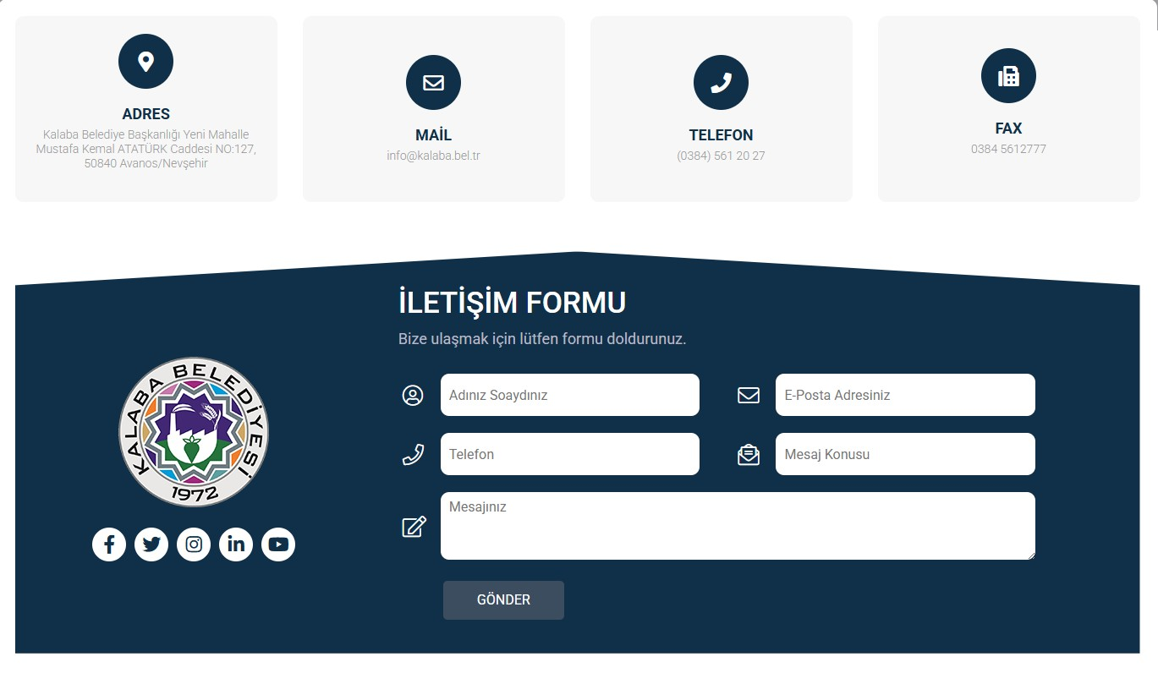

Figure 3.Kalaba Municipality Grievance Mechanism

If stakeholders are not satisfied with the solutions provided by the E&S team at the PIU of Kalaba Municipality or if they want further clarification, complaints, requests and suggestions can be forwarded to ILBANK through the communication channels provided below. ILBANK established a transparent and comprehensive GM in September 2021 to receive, evaluate and resolve complaints regarding each international project it finances.

* <https://www.ilbank.gov.tr/form/bilgiedinmeuluslararasi>
* +90 (312) 508 79 79
* bilguidb@ibank.gov.tr / etikuidb@ilbank.gov.tr

The grievances, requests, suggestions and opinions of the public will be recorded through the GM contact person (GMCP) to be assigned by Kalaba Municipality. All grievances are examined to be classified according to whether they are related to sub-project activities or not. If a grievance is deemed unsuitable for investigation because it is not genuine or not related to sub-project activities, the complainant will be provided with an explanation as to why the grievance could not be followed up. Grievances received within Kalaba Municipality are evaluated and forwarded to the relevant units. Appropriate grievances are responded to according to the sub-projects social and environmental requirements defined in the ESMP and SEP.

All grievances received through direct phone calls, e-mails, face-to-face meetings/communications and the Website are recorded and after the recording process, GMCP will contact the complainant to explain the sub-project response process and the resolution of the grievance within four (4) business days. The development of the solution may require consultation with the relevant person(s). The requester will be informed about the methodology followed. Each request must be evaluated with the utmost care, diligence, fairness and impartiality. The proposed solutions are communicated to the complainant with a second notification. If the proposed solution is accepted by the complainant, Kalaba Municipality PIU will handle the grievance within 15 business days and take corrective measures to resolve the grievance. Grievance registration forms will be sent to the relevant GM Team member (Social Expert of the PMU Team or E&S Expert of the Contractor) on the same day (if possible, as soon as the grievance is received). A notification should be sent to the complainant by GMCP within two (2) business days of the receipt of the grievance, indicating that the grievance has been received and evaluated. The PIU Team will also have access to the grievance record to be created within the scope of the sub-project and will be continuously updated by GMCP or PIU Social Expert. The Grievance Tracking Table will include the complainant/suggestor information, the date of receipt of the grievance/suggestion, the date and method of feedback to the complainant, the current status of the grievance (open, under review, closed, rejected) and the explanation of this current status (e.g. why it was rejected). It will include the closing/rejection and feedback dates. Grievances from contractors and subcontractors will be forwarded to GMCP by the Contractors’ E&S Specialist and will be recorded by GMCP using the grievance registration forms. On the same day, the data will be entered into the Grievance Registry and Grievance Database and made accessible to the PIU Team. During this period, the relevant parties responsible for managing the grievance will be in constant communication with the complainant and all communication will be recorded in the GM system through the Consultation Forms (see Annex-D). The grievance will be closed after the implementation of the decision is completed. After the grievance is closed or resolved, the complainant will be informed with the third notification and the relevant records (Grievance Closure Form, Grievance Record, etc.) will be kept. Unless an alternative agreement is made with the complainant, grievances will be closed within thirty (30) business days from the date of application. If the grievances are not resolved within fifteen (15) business days, the extenuating circumstances will be documented and reported. After the grievance is resolved and the result is communicated to the complainant, the appointed GMCP will obtain the necessary signatures and close the grievance by filling out the Grievance Close Out Form (see Annex-B). If the decision is not accepted, it will be reconsidered and a revised decision may be proposed. Ultimately, the PIUs will be responsible for consolidating, monitoring and reporting the requests received, resolved and pending regarding the project. All this data will be compiled by the PIU to be reported at the end of each month.

Kalaba Municipality/PIU Team will also implement additional measures to manage sensitive and confidential complaints, including those related to Sexual Exploitation and Abuse/Harassment (SEA/SH), in accordance with the World Bank ESF Good Practice Note on SEA/SH. ILBANK will intervene in sensitive matters, including cases related to SEA/SH.

## Grievance Mechanism for Workers

The GM for employees (applicable to both Kalaba Municipality personnel and contractor and subcontractor employees) has been established in accordance with WB ESS2. The implementation of the GM for employees will be ensured throughout the life cycle of the sub-project. PIU requests contractors to develop and implement a grievance mechanism for the workforce, including sub-contractors, before starting work. Sub-contractors will prepare labor management plans that will include a detailed description of the grievance mechanism for employees.

Employees are informed about employee rights, basic occupational health and safety, the grievance mechanism and its operation at the time they start work. An up-to-date list of contact points is available in employee handbooks and/or bulletin boards. All processes related to the grievance mechanism are conveyed in a language that employees can understand.

When employees detect a hazard or risk for which no precautions have been taken regarding occupational health and safety, they inform the employee representative, occupational safety specialist and/or occupational physician selected by the employees about this hazard or risk. The employee representative shall forward the details of the hazard and risk to the occupational health and safety board, if any, or to the employer/employer's representative, and request an evaluation. If the problem is not resolved, all legal rights are reserved by applying to the contractor/subcontractor level GM contact persons through the grievance drop-off points located at the workplaces. Requests regarding employee rights and occupational health and safety are collected in grievance boxes placed in areas that employees can easily access.

The collected grievances and suggestions are carried out in accordance with the periods determined in the process of the grievance mechanism.

After the applications are evaluated, if there is an imminent, urgent and vital danger, a notification can be made directly to the Labor Life Communication Center, ALO 170 line or the Provincial Labor and Employment Institutions Directorates operating in the province. Upon receipt of the requests, the workflow grievance mechanism is carried out in accordance with the workflow chart.

The Kalaba Municipality/PIU Team will be ready to handle grievances regarding working conditions. The Kalaba Municipality/PIU Team will evaluate grievances and suggest solutions for direct and contracted employees using this internal GM, which all sub-project employees can easily access.

## Grievance Mechanism Flow Chart

Grievance mechanism operation diagram details are given in Table 6.

Table 6. Grievance Mechanism Flow Chart

| **Grievance Process** | **Requirement / Action** |
| --- | --- |
| Submission of a grievance | Receiving the grievance by any communication channel explained above. (At this point, if the grievance is a sensitive grievance involving child abuse, sexual harassment abuse or Gender Based Violence (GBV) immediate action will be taken within 2 days after receiving of the grievance. For the cases relevant to sexual exploitation and abuse/sexual harassment at workplace or any potential child abuse in the project sites, the grievance will be directed by the GM focal point (based in ILBANK DG) to relevant legal authorities/service providers such as Ministry of Family and Social Services and Prosecutors Office.”) |
| Registration of grievance | Registering/recording through making an entry in the sample grievance register table. All the grievances will be registered within two working days and feedback will be given to the complainant. If the complainant requests that this grievance be treated anonymously, this grievance will be recorded anonymously and the request will be met. |
| Forwarding of grievance | The grievance is forwarded to relevant persons (site manager on construction sites and experts of the PIU) responsible for handling the grievance in not later than three working days upon receiving the grievance (except for any emergent grievance, which would be handled as appropriate). |
| Evaluation of a grievance | Evaluating the grievances within 10 working days and determining whether the grievance meets the admissibility criteria. If the grievance is not valid, providing relevant explanation to the complainant. |
| Response for a grievance | If the grievance is valid, identifying and taking corrective measures for resolving the grievance in not later than 15 working days upon receiving.  All comments and grievances will be responded to either verbally or in writing, in accordance with the preferred method of communication specified by the complainant, if contact details of the complainant are provided.  At this point, it should be noted that the action taken and the result of this anonymously recorded grievance should be shared on the Kalaba Municipality website, so that anonymous complainants is informed about their grievance and the results. |
| Recording the result of a grievance | Recording the result of the grievance in register table. |
| Right to Appeal | If the grievance cannot be resolved with the existing process, applicants can always apply to relevant legal institutions. Such institutions can be summarized as follow:   * Civil Courts of First Instance * Administrative Courts * Commercial Courts of First Instance * Labor Courts, and * Ombudsman (https://ebasvuru.ombudsman.gov.tr/) |

# MONITORING AND REPORTING

## Summary of how SEP implementation will be monitored and reported

It is the responsibility of Kalaba Municipality to ensure that the SEP is fully integrated and implemented in all sub-project activities. All stakeholders will be consulted and will be able to use the GM throughout the sub-project lifecycle. On the other hand, the SEP will form part of all tender documents related to the physical works within the scope of the sub-project.

As part of the World Bank ESF requirements, the draft ESMP and SEP will be made public when approved for public disclosure and approved by İLBANK, and the disclosure will be the responsibility of the sub-project Implementers and the consultant firm. Kalaba Municipality will ensure that the SEP is published in hard copy and on its website. Similarly, several copies of all prepared environmental and social documents will be available locally in Kalaba Municipality, where affected groups such as the Mukhtar offices operating in the Avanos District of Nevşehir Province and local NGOs can easily access. The SEP is a dynamic document and will be reviewed, updated and approved by ILBANK when necessary (e.g. changes in the design of sub-project components according to Environmental and Social Monitoring Reports (ESMRs), stakeholders' requests/grievances regarding the sub-project. Implementation of the SEP throughout the implementation of the sub-project, elimination of non-conformities, etc.). Kalaba Municipality will be responsible for making a statement through communication channels for each updated version of the SEP.

Kalaba Municipality will monitor the sub-project throughout its lifetime considering the stakeholder engagement process. The approved SEP will be reviewed biannually and updated if required according to the project improvements and the unexpected public reactions. The GM established by the Kalaba Municipality will be used effectively and the statistical summary of the outputs of GM will be reported to ILBANK together with all the requests received, resolved and unresolved, Grievance Register, Grievance Monitoring Table and Environmental and Social Monitoring Reports (ESMRs) on a quarterly basis. With quarterly reporting, total number of grievances, monthly number of grievances, distribution of grievances by subject, gender, grievances answered within 1 days, grievances resolved within 30 days, list etc. is necessary.

## Reporting back to stakeholder groups

The PIU Team will systematically record and report feedback received from communities, local governments, landowners, other companies, NGOs, media, academic institutions and other interest groups through an effective consultation and grievance mechanism to ILBANK.

The PIU Team will submit feedback and grievances, as well as a statistical and qualitative analysis of their results, to the Supervisory Consultant on a monthly basis, who will review and distribute them to ILBANK PMU. In addition, relevant grievances and their actual status will be reported in the ESMRs. Only the necessary information regarding the grievance will be included in the reports, and any personal information belonging to the persons using the ESMR will be kept confidential and will not be shared in these reports.

During the sub-projects’ development and construction phases, the construction contractors will prepare brief monthly reports on environmental and social performance for Kalaba Municipality which will include an update on implementation of the stakeholder engagement plan and include indicators in this section. The construction contractors will record SEP activities with monthly and quarterly reports and submit them to Kalaba Municipality and İLBANK.

Kalaba Municipality’s PIU, will report back to stakeholder groups, primarily through stakeholder consultation meetings in project affected municipalities and/or Neighborhoods. Minutes of meetings will be shared with participants during subsequent public meetings. The summary will be published after removing identifying information on individuals to protect their identities in accordance with the Law on the Protection of Personal Data. Feedback received through the GM will be responded to in writing and verbally. Key sub-project updates will be posted on Kalaba Municipality's website.

The summary will be published after the identity information of the persons is removed in order to protect their identity in accordance with the Personal Data Protection Law.

Kalaba Municipality will work with a consultant if necessary to carry out social and environmental monitoring activities. The Supervisor Consultant will monitor whether the environmental and social issues specified in the SEP and ESMP documents are implemented throughout the sub-project lifecycle and report to Kalaba Municipality.

# ANNEXES

## Annex-A

Sample Grievance Submission Form

|  |  |  |  |  |  |
| --- | --- | --- | --- | --- | --- |
|  | | **KALABA MUNICIPALITY**  **SOLAR POWER PLANT PROJECT** | | | |
| **GRIEVANCE FORM** | | | |
| Person Filling Out the Form: | | | | Date and time: | |
| Interview Agenda: | | | | Reference No: Kalaba Municipality-Project Code-0001-2.. | |
| 1. **INFORMATION ABOUT THE COMPLAINANT** | | | | | |
| Name surname:  *If the complainant requests that this grievance be treated anonymously, this grievance will be recorded anonymously and the request will be met.* | | | | **How received the Grievance:** | |
| TC Identification number: | | | | Telephone / Toll Free Line | |
| Telephone: | | | | Face to Face Meeting | |
| Address: | | | | Website / Email | |
| Email: | | | | Other (Explain) | |
| **Stakeholder Type** | | | | | |
| Public | PAP | Private Enterprise | Trade Association | | NGO |
| Interest Groups | Industrial  Association | Labor Union | Media | | University |
| 1. **DETAILED INFORMATION ABOUT THE GRIEVANCE** | | | | | |
| Description of the grievance: | |  | | | |
| Solution method requested by the complainant | |  | | | |
| **Registrant Name Surname/Signature** | | **Complainant Name Surname/Signature** | | | |

## Annex-B

**Sample Grievance Close Out Form**

|  |  |  |
| --- | --- | --- |
|  | **KALABA MUNICIPALITY**  **SOLAR POWER PLANT PROJECT** | |
| **GRIEVANCE CLOSE OUT FORM** | |
| Reference form: | | |
| 1. **DETERMINATION OF CORRECTIVE ACTION** | | |
| 1 | |  |
| 2 | |  |
| 3 | |  |
| 4 | |  |
| 5 | |  |
| 1. **CLOSE OUT THE GRIEVANCE** | | |
| *This section will be filled and signed by the Complainant in case the grievance stated in the “Grievance Registration Form” is resolved* |  | |
| **Name Surname /**  **Signature of the Person**  **Closing the Grievance/Date** | **Name Surname /**  **Signature of Complainant/Date** | |

## Annex- C

Grievance Database Form

|  |  |  |  |  |  |  |  |  |  |  |  |  |  |  |  |  |  |  |  |  |  |
| --- | --- | --- | --- | --- | --- | --- | --- | --- | --- | --- | --- | --- | --- | --- | --- | --- | --- | --- | --- | --- | --- |
| **No** | **Complaint Register  Number** | **How Complaint is Received (Grievance Form, Community Meeting, Telephone)** | **Level of Grievance (Municipality/Utility Level, Regional)** | **Date of Complaint  Received** | **Location of Complaint  Received** | **Name of Person Receiving Grievance** | **Land Parcel # (If complaint is related to land)** | **Complainant Information** | | | | | **Project Component Related to Complaint** | **Grievance Category (expropriation/land acquisition related, environmental issues, damages to structures etc.)** | **Complaint Summary** | **Grievance Status (open, closed or pending)** | **Action Taken** | | | | **Supporting Documents for Grievance Closeout (bank receipt for compensation, grievance closure protocol)** |
| **Name/Surname** | **ID Number** | **Telephone/ email** | **Village-District** | **Gender** | **Responsible Person/Department** | **Action Planned** | **Due Date of the Addressing the Grievance** | **Date of Action Taken** |
| **1** |  |  |  |  |  |  |  |  |  |  |  |  |  |  |  |  |  |  |  |  |  |

## Annex-D

Sample Consultation Form (For Stakeholder Engagement Meeting(s))

|  |  |  |  |  |  |
| --- | --- | --- | --- | --- | --- |
|  | | **KALABA MUNICIPALITY**  **SOLAR POWER PLANT PROJECT** | | | |
| **CONSULTATION FORM** | | | |
| Person Filling Out the Form: | | | | Date time and place: | |
| Meeting Agenda: | | | | Interview Registration Number: | |
| 1. **INTERVIEW INFORMATION** | | | | | |
| Interviewed Institution: | | | | Form of Communication | |
| Name and Surname of the Interviewee: | | | | Telephone / Toll Free Line | |
| Telephone: | | | | Face to Face Meeting | |
| Address: | | | | Website / Email | |
| Email: | | | | Other (Explain) | |
| **Stakeholder Type** | | | | | |
| State agency | PEB | Private Enterprise | Job Room | | NGO |
| Interest Groups | Industrial Unions | Labor Union | Media | | University |
| 1. **INTERVIEW DETAILS (**List of Invitees and actual participants, Summary of presentations made by whom, minutes of meeting will be annexes of this form.) | | | | | |
| Questions about the project: | |  | | | |
| Concerns/feedback regarding the project: | |  | | | |
| Responses to the views expressed above: | |  | | | |

## Annex-E

Consultation photos

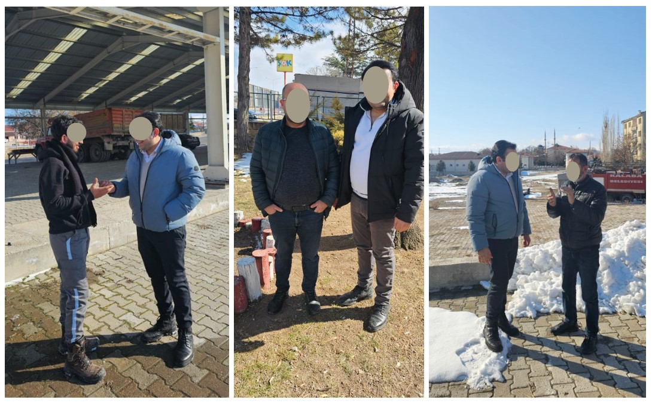

## Annex-F

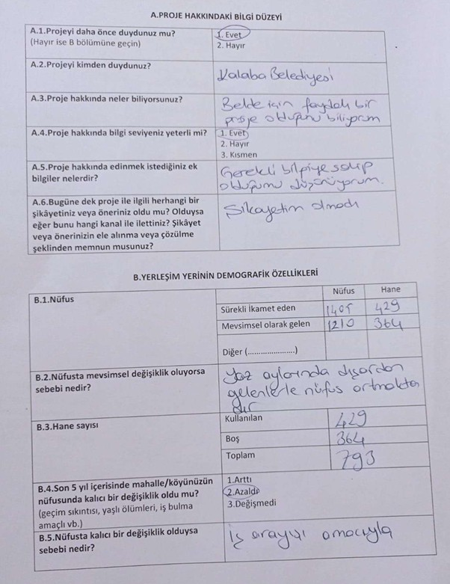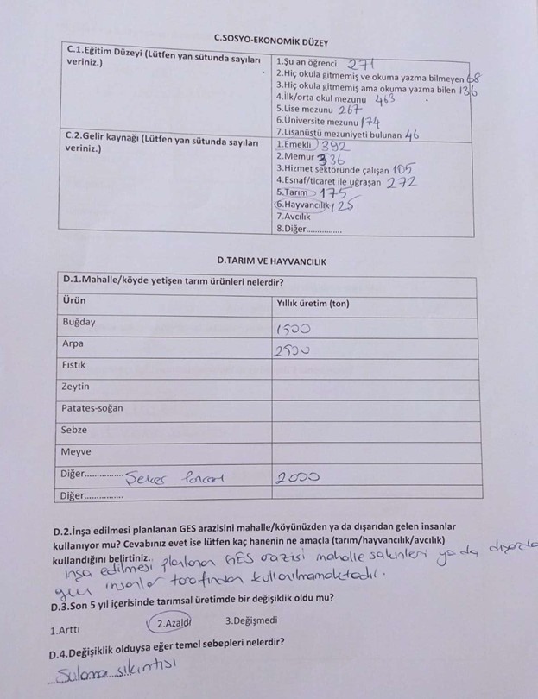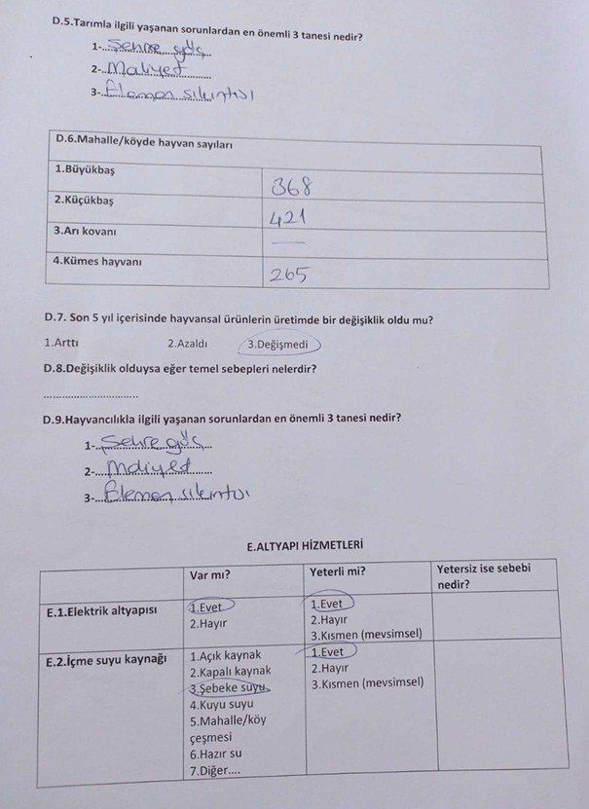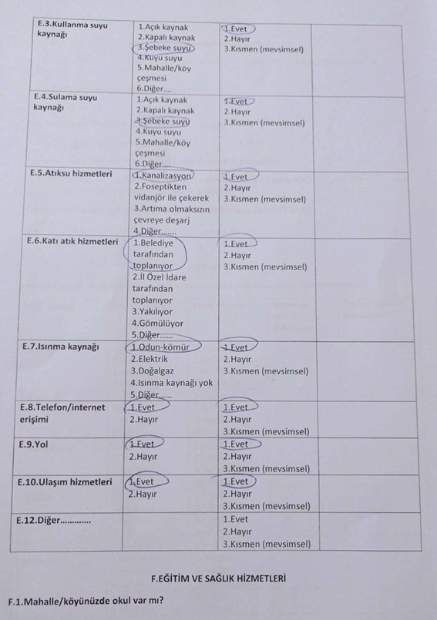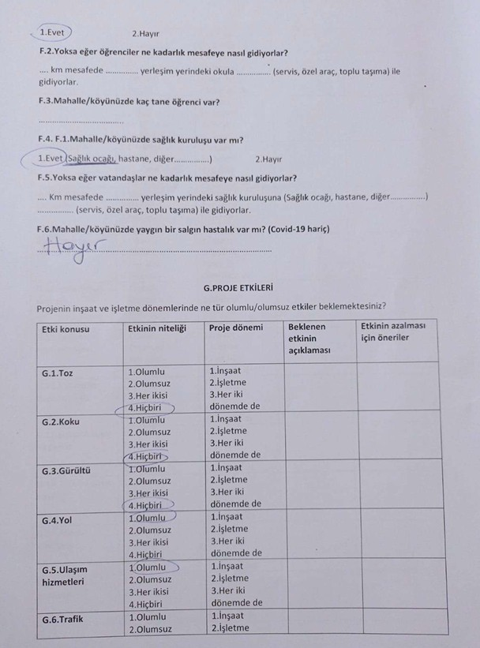

## Annex-G

**Türkiye Public and Municipal Renewable Energy Project (PUMREP)**

**KALABA MUNICIPALITY**

**SOLAR POWER PLANT PROJECT**

**Minutes of Public Consultation Meeting**

**Meeting Date: 10.06.2025**

**Meeting Time: 15:00**

**Meeting Venue: Kalaba Municipality Condolence House**

**PUBLIC CONSULTATION**

Kalaba Municipality Solar Power Plant Project is among the subprojects within the scope of Türkiye Public and Municipal Renewable Energy Project (PUMREP) which was created to support sustainable development in cities in Türkiye.

The Environmental and Social Management Plan (ESMP) was prepared in accordance with the requirements of the PUMREP Environmental and Social Management Procedures, ILBANK’s Environmental and Social Management Framework (ESMF), and the national environmental legislation of the Republic of Türkiye. As part of the stakeholder engagement process, a public consultation meeting was held on 10.06.2025 at 15:00 at the Kalaba Municipality Condolence House. In order to announce the meeting to the local people, the meeting information was published on the Kalaba Municipality website, in local and national newspapers, and local people were invited to the meeting with posters hung in the municipality building and brochures distributed to the public.

## Meeting Summary

The Minutes of Public Consultation Meeting (MoM) started with the opening speech of the Kalaba Mayor, detailed information was given about the process and content of the reports prepared by the consultant company representative for the implementation of the sub-project. The benefits of the sub-project to the municipality and the local people were mentioned. The meeting was conducted in the form of a verbal presentation due to the unavailability of projection and similar equipment within the municipality’s technical capabilities.

Within the scope of the MoM, the area where the sub-project will be established (as a neighborhood, block and parcel), project power, equipment to be used and technical specifications, the annual production of the project were mentioned and information was given that the legislative obligations were met.

A total of 40 people attended the meeting, 29 of whom were municipality members and 11 were local people.

Within the scope of the meeting; the consultant company environmental expert conveyed the environmental and social risks of the sub-project from the content of the ESMP Report, the works planned to prevent the said risks, the effects of the geographical location of the region where the project will be located and the climate conditions on the project and the analyses made on possible natural disasters. In line with the information provided, the meeting was concluded with questions and answers and lasted approximately 1 hour.

## ****Question and Answer Section****

|  |  |
| --- | --- |
| **Question 1.** | |
| Name / Occupation | Personnel of Kalaba Municipality |
| Do the panels cause additional temperature increases in their surroundings? | |
| **Answer 1.** |  |
| Name / Occupation | CA Engineering |
| Yes, the panels convert the sun's rays into energy and emit a very small portion of it as heat. However, this heat usually remains within the wire fence surrounding the field. It is not a situation that will negatively affect daily life or the ecosystem surrounding the field. | |

|  |  |
| --- | --- |
| **Question 2.** | |
| Name / Occupation | Citizen |
| Will there be noise during production during the operation phase? | |
| **Answer 2.** |  |
| Name / Occupation | CA Engineering |
| No, no noise is added during the operation phase due to production. There may be very low levels of noise during maintenance or repair operations. This is not at a level and duration that will affect the environment. | |

## Meeting Conclusion

The Public Consultation Meeting lasted approximately 1 hour, with the consultant company officials providing information about the project and Q&A. Information was provided on the environmental, social and economic dimensions of the Kalaba Municipality SPP project, as well as the next stage of the subproject. The meeting was concluded after consultation with the participants' opinions and suggestions.

## **Participant List**

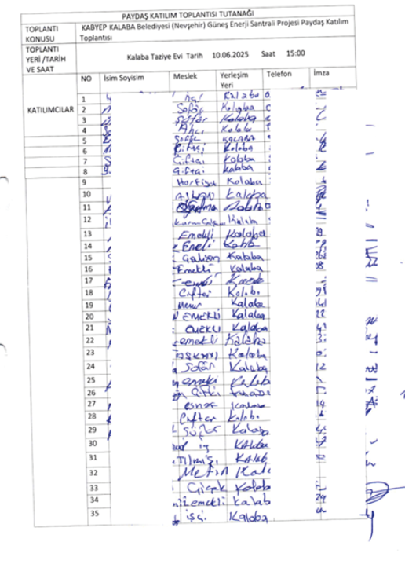

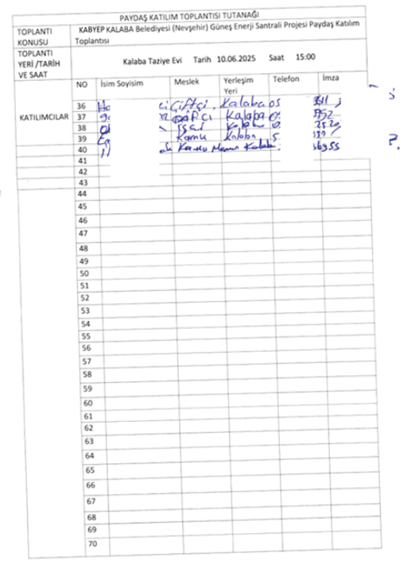

# ATTACHMENTS

## Annex-1: Photo of the Public Consultation Meeting (10.06.2025)

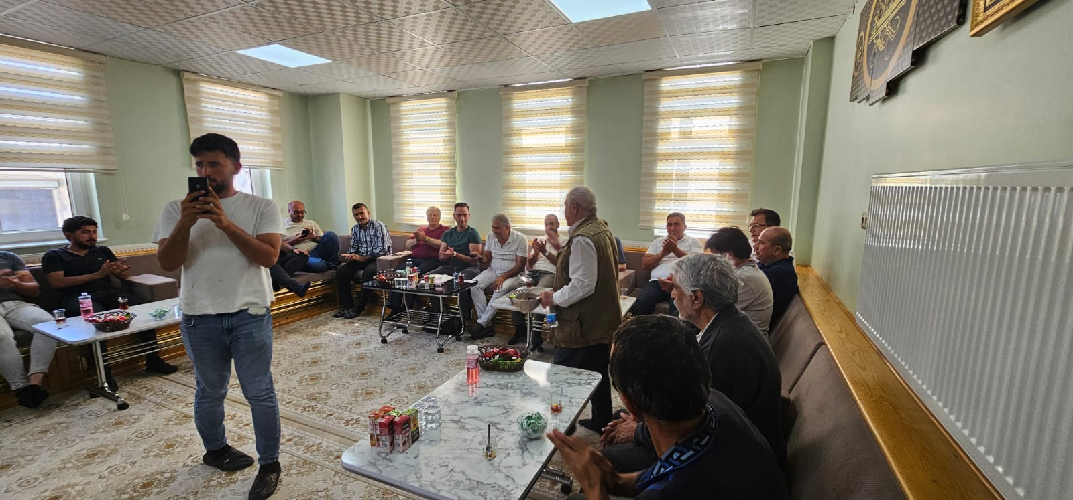

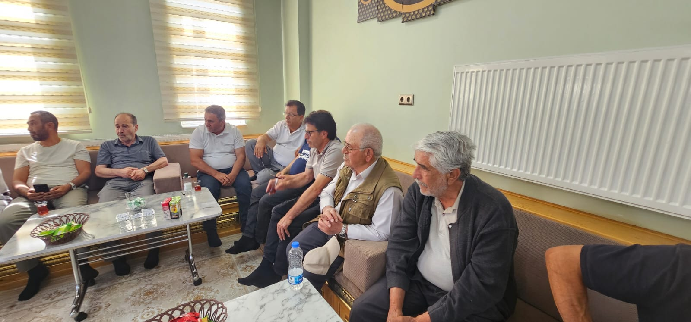

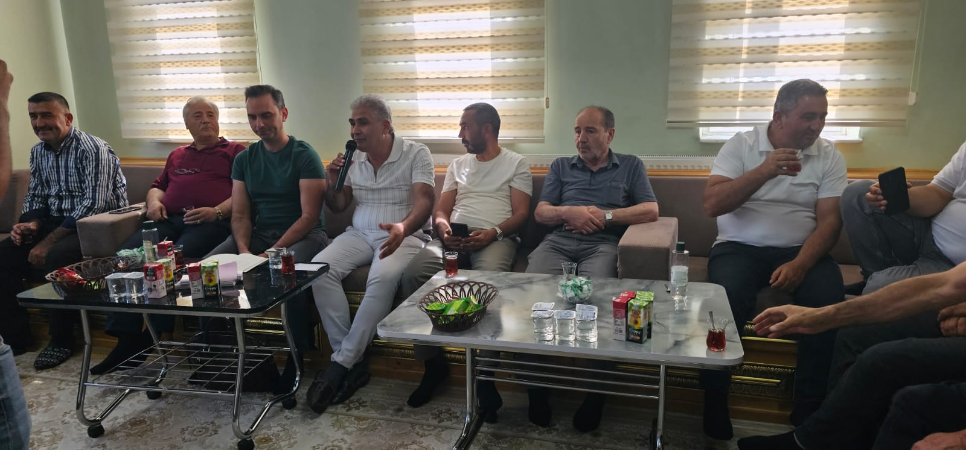

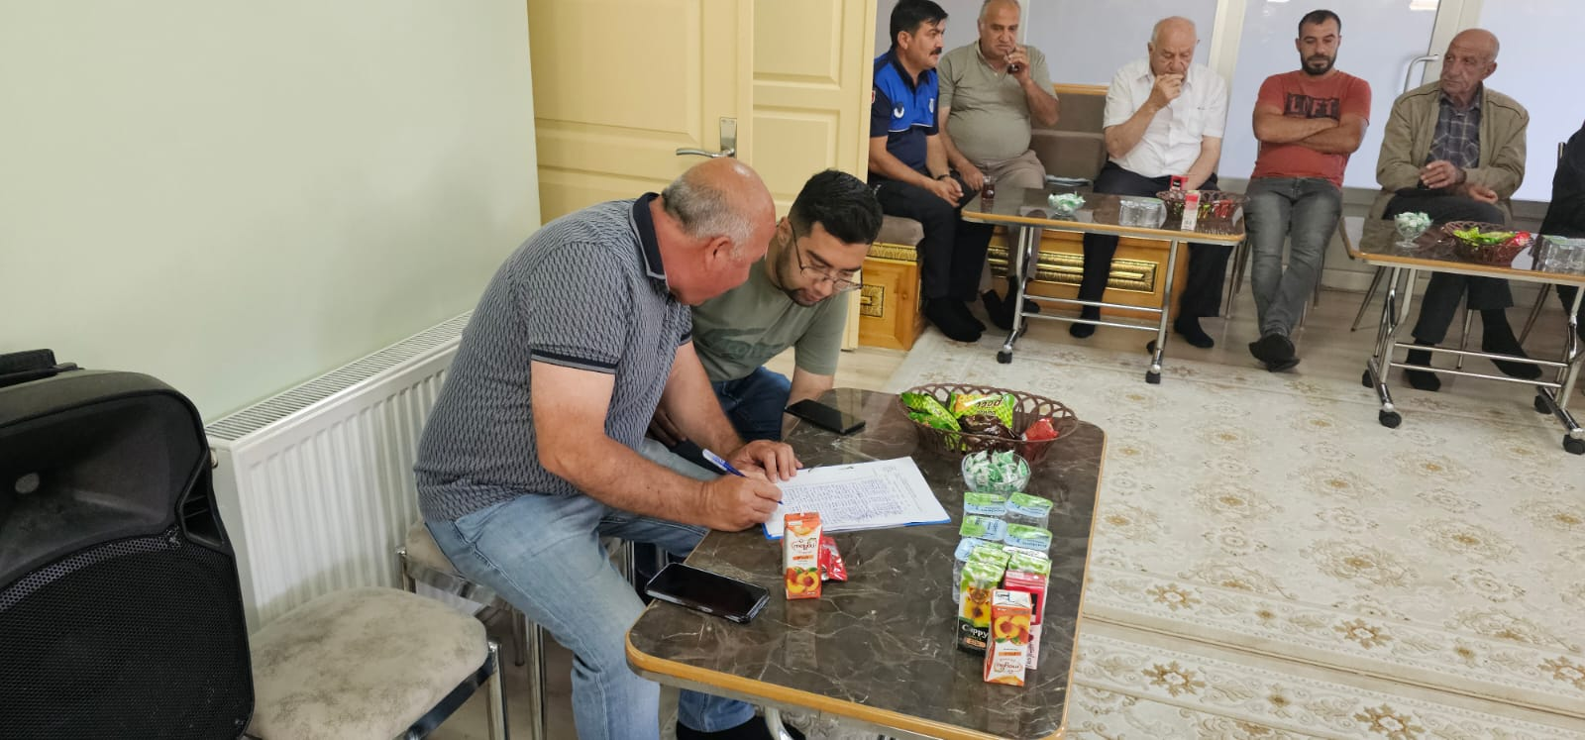

## Annex-2: National Newspaper Advertisement (Newspaper Announcement Date –YeniBirlik, 26.05.2025)

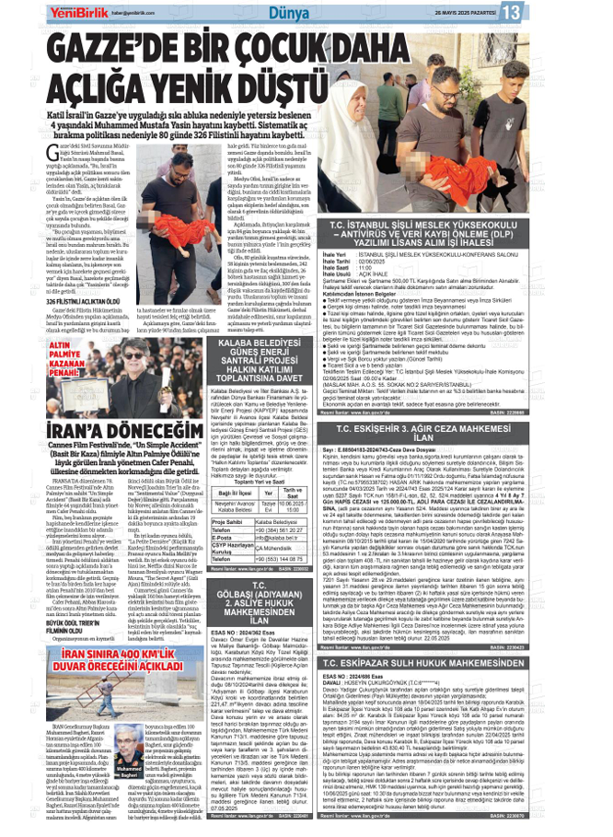

## Annex-3: Local Newspaper Advertisement (Newspaper Advertisement Date – Muşkara News -26.05.2025)

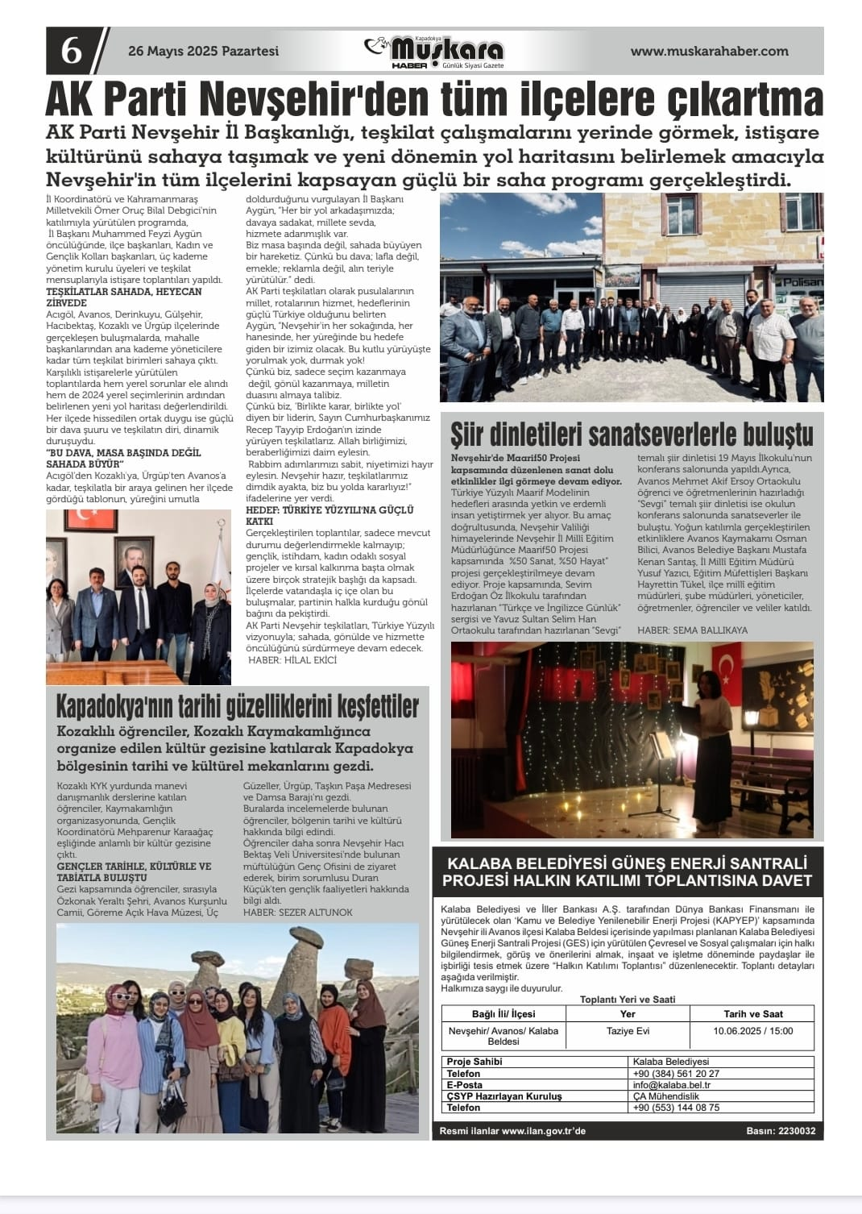

## Annex-4: Kalaba Municipality Website, Announcements (23.05.2025)

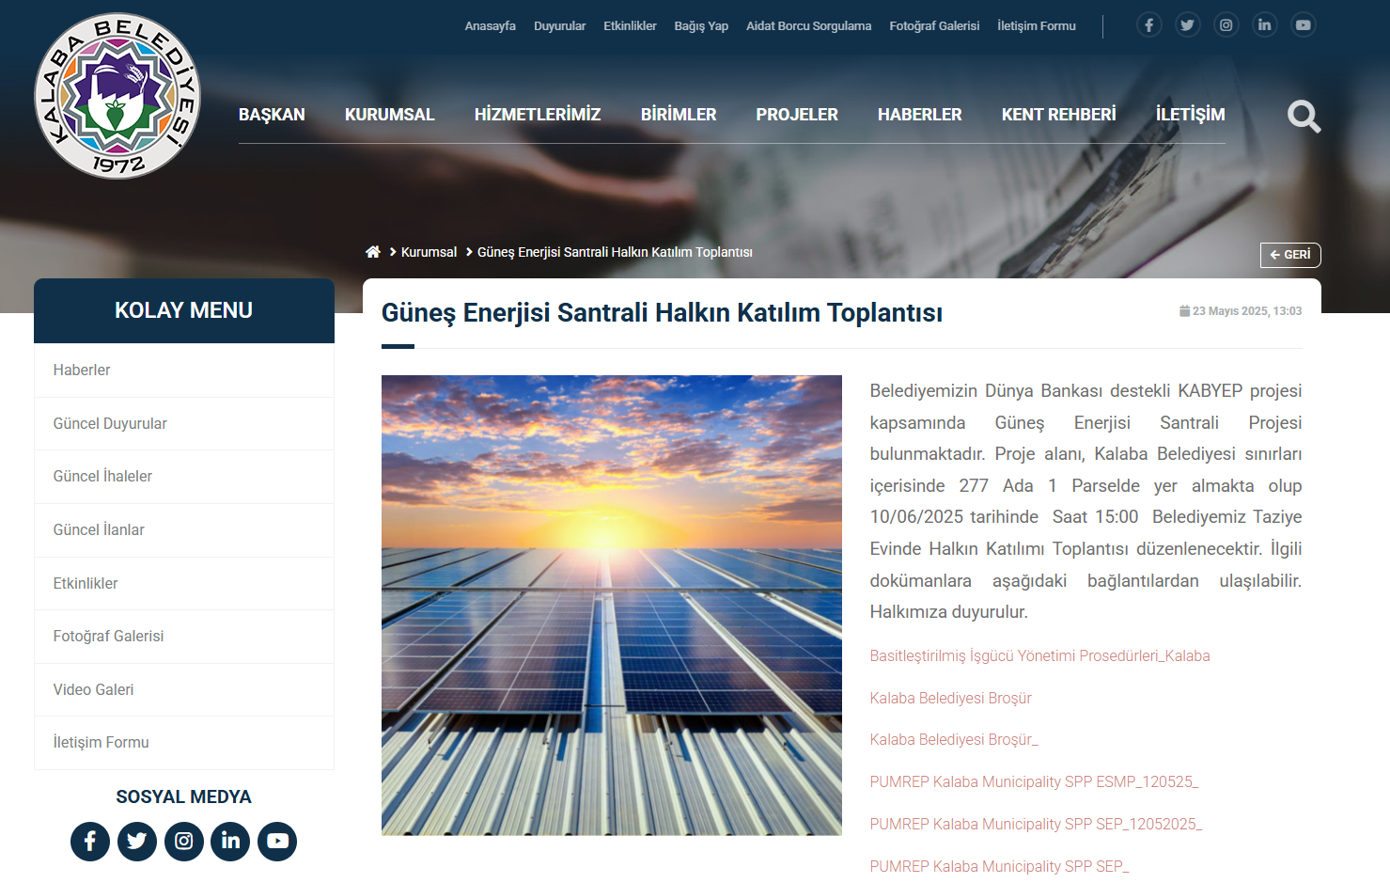

## Annex-5: Kalaba Municipality Public Consultation Meeting Brochure

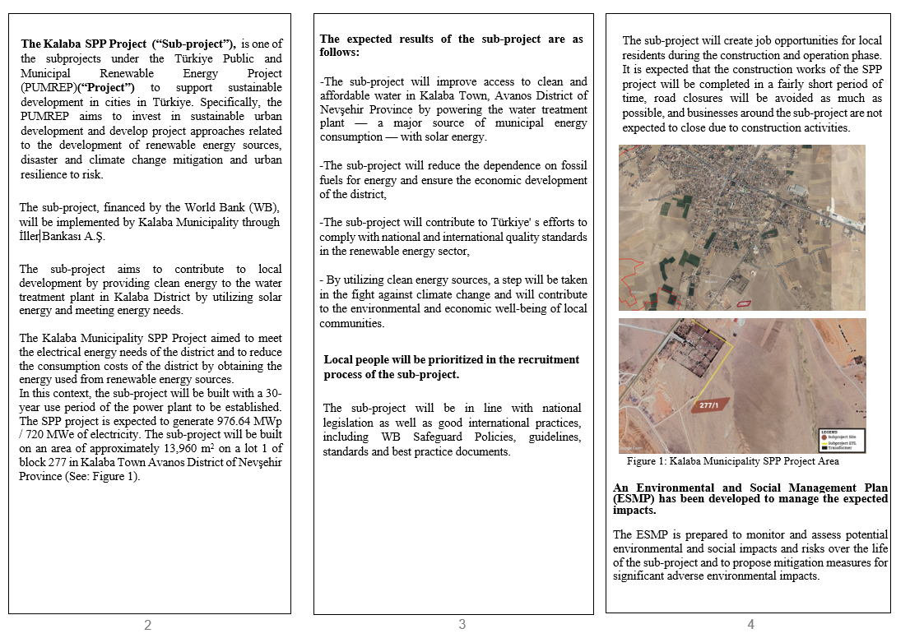

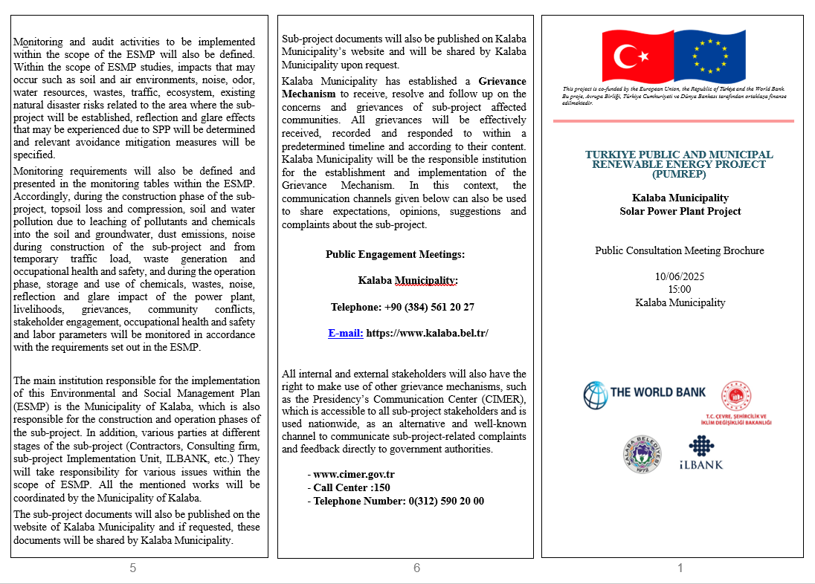

## Annex-6: Kalaba Municipality Notice Board

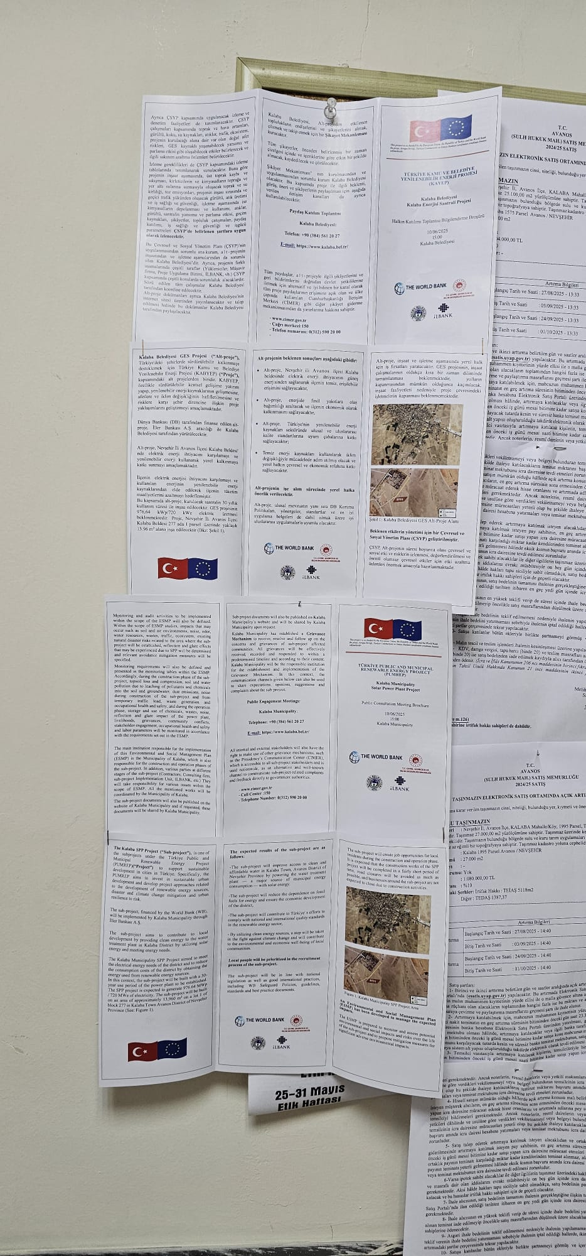 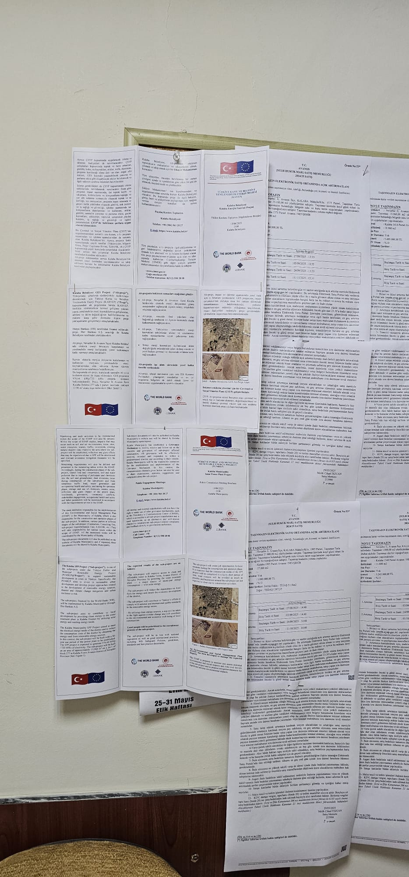

1. After the ESMP report is published on the Kalaba Municipality website, the link will be added to this section.
2. https://www.kalaba.bel.tr/